VAICOM
Interactive Voice Control Plugin for DCS World



Community Edition
Version 3.1.8


User Manual

Manual Revision
Release 3.1.8.3
October 2026

INDEX
2

PREFACE 3
INTRODUCTION 4
NEW IN THIS VERSION 5
QUICK SETUP GUIDE 6
PUSH-TO-TALK SETUP GUIDE 13
USING VAICOM 16
MULTIPLAYER 24
THE CONFIGURATION WINDOW 29
KEYWORDS TRAINING MODE 42
ADVANCED CONFIG & DCS UPDATING 44
INTERACTIVE KNEEBOARD EXTENSION 47
AIRIO DIALOG EXTENSION 51
DIALOGS TRAINING REFERENCE 55
KEYWORDS REFERENCE 57
EXPOSED VARIABLES 96
PLUGIN API 97
TROUBLESHOOTING GUIDE 99

PREFACE
2

On 31 OCT 2022 Hollywood_315 open sourced VAICOM PRO, his awesome AI communications software for DCS Word. VAICOM PRO has been the launch pad for VR pilots in DCS to create a immersive environment free from the constraints of keyboard or mouse-controlled radio menus.

A group of community members have taken over the upkeep of the software to ensure virtual pilots remain keyboard free while flying DCS. We also just hit 4000 members on the Vaicom Community Discord! This is a big number and reminds me how important the plugin is for many virtual pilots.

Version 3.1.7.5 represented a major update for Vaicom. OpenKneeboard Out V2 is another major advance in extracting DCS runtime information and making it useful to the pilot. This will provide a very quick way to access the information you need without the effort of making your own kneeboard documents and provide a highly detailed flight planning calculator hidden in the backend of the NAVLOG feature. The addition of an internal GPS powered kneeboard EFB with Moving Map is game changing.

This manual has been updated to reflect the current state of VAICOM and the inclusion of the new OKB Out V2 features.

We owe our gratitude to Hollywood_315 for this amazing application, and Community Fixers and testers for keeping it a viable option for virtual pilots everywhere.

Anyway, we hope you enjoy VAICOM 3.1.7.5 and stay immersed in the DCS VR world.

-Pene on behalf of VAICOM Community Team

INTRODUCTION

Welcome to the VAICOM Community!

For unleashing the full immersive potential of Eagle Dynamics’ cutting-edge combat flight simulation DCS World, the cumbersome menu-based interaction for communications has traditionally been one of the major stumbling blocks. On-screen menus not only block the view but also take unnatural and time-consuming F-key keyboard steps to send even the simplest radio message to an AI unit. For a truly realistic and immersive combat flight experience something far more advanced is needed.

Enter VAICOM. VAICOM Community Edition is a unique plugin for Voice Attack which links advanced voice recognition directly into the DCS core engine. This allows for a deeply immersive experience. With its 100% keyboard- and menu-free approach VAICOM is the ideal complement for your HOTAS and (VR or regular) headset setup.
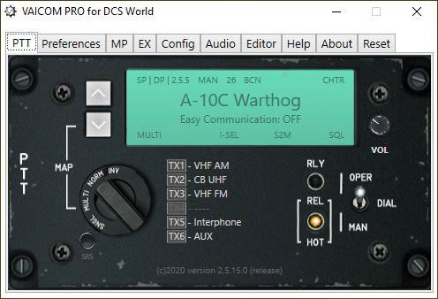
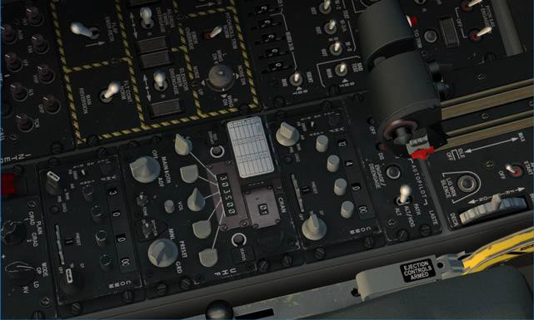

Built on a UDP/JSON network interface, VAICOM Community unlocks the full breadth of AI radio communications as a natural and transparent extension of the DCS simulation environment. Forget about sluggish F-keys and don’t let on-screen menus interfere with the view. With VAICOM PRO Community, the menu system is bypassed. You communicate with all airborne and ground-based AI units in real-time using only your voice and your aircraft radio devices just like in real life.

With the new interface design, standard VA limitations such as keyboard locale dependencies, potential flow sync issues, incidental view switches etc. are things of the past. Setup has never been easier. VAICOM Community has no dependencies on any external apps or mods but is compatible to work alongside your other favourite peripheral tools.
VAICOM Community has a wide range of options and features that can be directly controlled from its configuration window. It works with all current DCS aircraft modules, and even has auto-configuration features for new aircraft modules and theatre releases. This User Manual document contains all the detailed information for setup, configuration, and usage.

Happy flying!

NEW IN THIS VERSION


VAICOM PRO plugin 3.1.8.3

Updates since the last release, focused on OKB Out workflow reliability, AH-64D/George command handling, TX-Link behaviour, and F-14 AIRIO improvements. Includes new AID controls, expanded EFB with history-track management, and multiple command-flow bug fixes across modules.

Major additions
• Added OKB Out AID (Aircraft Interface Device) connection with STORES control and new FUEL data block live-feed fuel metrics.
• Added new AH-64D George pilot commands and backend workflow updates.
• Added new AH-64D hot-start pilot takeoff commands and aircraft state monitoring
• Added new TX-Link implementation with combined-module case logic reworked from scratch.
• Added Jester Wheel visibility external-context commands to manually toggle wheel visibility via voice, button, or key presses in Voice Attack.
• Added collapsed-run handling for numeric F-14 commands such as Radio Frequency, Laser Code, and Link Tune (requires Voice Attack profile command updates).
• Added OKB Out EFB Moving Map history-track and persistent track layer management drawer controls.
• Added route-altitude import support in OKB Out DTC Flight Plan import when altitude is specified during DTC construction.
.
Improvements
• Reworked OKB Out Page command and Auto Browse behaviour; page commands no longer require Auto Browse to be enabled.
• Refined OKB Out AWACS tab to include active/radiating SAM radars, grouped AIR/SAM/EWR contacts, and sorted-by-range output (AWACS must be on task).
• Added NAVLOG heading toggle support for metric Speed, ALT, and DIST units in OKB Out.
• Updated F-14 AIRIO EGI navigation commands and added a resolver pass to avoid conditional waypoint issues.

Fixes
• Fixed TX-Link short-press behaviour and ICS gating.
• Fixed potential loss of function keys due to menuvisible().
• Fixed numerous AH-64 pilot command bugs.
• Minor Hide Menus handling fix to keep communicator availability on affected modules when menus are hidden.
• Removed old debug logging paths.

QUICK SETUP GUIDE

If you are an experienced user, here’s the quick summary guide to get you started quickly. It is still recommended to read through this User Manual at least once since there are quite a few areas that require specific attention.

Here is the quick start summary:

- Make sure Voice Attack runs as administrator, and plugin support is enabled.

- Download the plugin installation file from the GitHub.

- Installation instructions can be found in the release.

- Download and run the MSI installer.

- Now launch Voice Attack and configure Voice Attack settings in the options window (for details see the ‘Voice Attack options’ section further down this document).
- Also check DCS options,
- Next, import the profile ‘VAICOM PRO for DCS World.vap ‘ from the ‘Profiles’ subfolder. This is created after the first run of Voice Attack with Vaicom Pro installed.
- In the profile, assign the HOTAS buttons and/or keyboard keys you want to use for Push-To- Talk. Make sure to set up both the ‘Press’ and ‘Release’ command for each button.

- Press LCtrl+LAlt+C to open the plugin configuration window. It has several pages.
- Launch a mission in DCS World and try out some voice commands using PTT. Check the PTT tab to see the current PTT mapping layout. With DCS World running, keep the plugin config window open to try out various options (Preferences page) by switching them on and off.

- Export the keywords database as .csv file from the keyword editor page to have a handy readout of the full keywords set (there are some 1065 keywords in the standard library).

- Use the Keywords Editor and Training Mode to finetune things further to your needs.

SYSTEM SETUP AND CONFIGURATION

Below is the detailed setup guide for VAICOM.

System Requirements

- Windows 10 or 11
- Voice Attack 1.16 or 2.1.6 Paid Edition recommended due to number of commands.
- DCS World 2.9 or higher

Before installation
 Before installation note the following:
  - Voice Attack needs to run as admin. Inspect the VA desktop shortcut by right clicking and in the Compatibility tab select ‘run this program as administrator’.
  - VAICOM PRO does not require any mods or external tools (such as Auto Hotkey and what have you) to be installed. If you use mods that’s fine as these should under normal circumstances not conflict with VAICOM PRO.
  - VAICOM PRO automatically re-configures after bi-weekly DCS version updates without user intervention needed. Do restart Voice Attack and then start DCS after a DCS World update.
  - Manual DCS-side (.lua) files installation should normally not be needed as this is automatically done by the plugin on initialization. Manual install of .lua files is not recommended unless for advanced users deploying a custom setup.
  - If your Windows account does not have sufficient privileges this could potentially lead to issues but most likely things will still work without problems. If you can run Voice Attack without issues on your system then VAICOM PRO should generally be fine also.

Network

VAICOM PRO uses network protocols for data exchange. Make sure you open the Windows Firewall for Voice Attack/VAICOM PRO if necessary (you will automatically be prompted by Windows in that case) and make sure Antivirus is not blocking. For reference VAICOM PRO uses IP ports 33333, 33334, 33491 and 33492 and 44111, all on UDP protocol.

Note for STEAM users

If you run DCS STEAM edition and the plugin does not work as expected after initial installation, run a DCS Repair and delete the export.lua file from Saved Games. Then select the Custom Path option on the Config tab. Set the slider to steam. Click SET to select the DCS program files folder and restart both Voice Attack and DCS. This will make sure the required .lua code is put in the right location.

PLUGIN FILES INSTALLATION

Prerequisites

Before installing the VAICOM plugin have the following installed on your system:

  - DCS World 2.9 or higher
  - Voice Attack (versions 1.16.0, 2.1.6 or higher)
  - A decent-quality microphone/headset suitable for voice recognition.

Auto Installer Package (MSI)
Uninstall your previous version of VAICOM PRO via the Remove Apps function in windows. Then simply run the installer and follow the instructions. If you do not uninstall previous versions you will be prompted by the installer.

Manual Plugin files install

Then if you haven’t done so yet download the VAICOM PRO plugin latest version from the GitHub

Extract the downloaded .zip file. 
VAICOMPRO.zip

Inside the zip is a folder named VAICOMPRO. This VAICOMPRO folder with its contents needs to be placed in the Voice Attack Apps folder. Typically, this is located at

C:/Program Files/Voice Attack/Apps/
Note: Older VA installers may use the (x86) folder instead. Inspect both folders if needed.

, drag the VAICOMPRO folder with its content in there so that this becomes:
C:/Program Files/Voice Attack/Apps/VAICOMPRO/

.. and that’s it for the base installation. There is no mods or other software to install. Proceed with setting the Voice Attack options.

INSTALL TROUBLESHOOTING
Carefully follow the install steps on the next pages. Things somehow not working? Refer to the separate Troubleshooting Guide at the end of this document or visit the Discord.

SETTING VOICEATTACK OPTIONS
Configure Voice Attack without DCS running. First of all, start Voice Attack and make sure it runs as admin. To confirm this, inspect the properties of the Voice Attack shortcut on your desktop and verify that the ‘run this program as administrator’ option is checked in the Compatibility tab.

In Voice Attack, open the Options window by pressing the wrench icon.
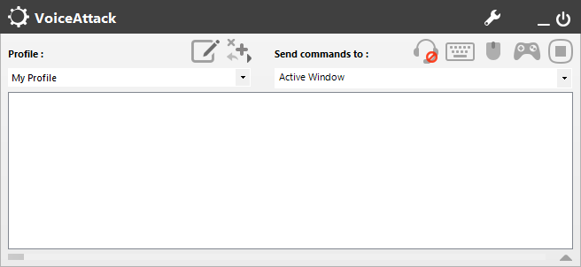

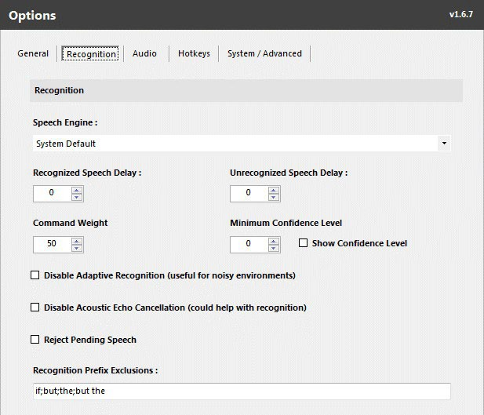
In Voice Attack options window apply the following settings:

Note: On the Recognition page the Windows Speech Recording Device is set, make sure it matches the microphone device you are using and that the input signal is sufficiently strong. The VA audio bar is a good indicator: this should show a wide range of deflection while speaking. Optionally (un)check the Disable Adaptive Recognition and Disable Echo Cancellation options to improve signal quality if you have problems getting adequate recognition. Proper mic placement is important for input quality: a headset setup is recommended. Avoid audio driver tools like Sonic Suite, these can cause issues.

TAB GENERAL

  - Enable Plugin Support: ON
  - Joystick Options: (enable HOTAS devices here you intend to use with PTT)

TAB RECOGNITION

  - Speech Engine: System Default or select the engine you intend to use.
  - Recognized Speech Delay: 0 (zero)
  - Unrecognized Speech Delay: 0 (zero) Note: for VSPX processing set to 700, see page 18.
  - Command Weight: 85 or higher recommended.
  - Minimum Confidence Level: 60 or higher recommended.

TAB AUDIO

  - Notification Sounds: OFF
  - Sound File Volume Offset: 100%
  - Audio Output Type: Integrated Components TAB HOTKEYS
  - Recognition Global Hotkey: Disabled
  - Mouse Click Recognition: None
  - Joystick Button Recognition: Disabled
  - Stop All Commands Hotkey: Disabled TAB SYSTEM / ADVANCED
  - Cancel Blocked Commands: ON

When done with setting these options, import the Voice Attack profile (.vap file) called ‘VAICOM PRO for DCS World’ in the Profiles subfolder (the plugin will have automatically created several subfolders on initialization). After the profile is imported, restart Voice Attack.

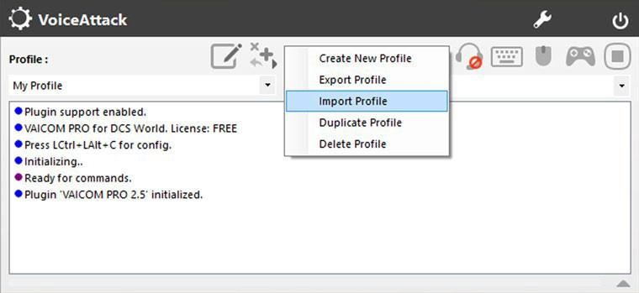

Note: with VAICOM PRO you will only use this single Voice Attack profile for all DCS modules. You do not switch profiles. VAICOM PRO automatically detects the active DCS aircraft module and instantly adjusts its settings internally without the need to manually switch aircraft or to refer to another profile in Voice Attack.

When the profile loads for the first time you may get a warning message. If so, simply press YES to accept and continue.

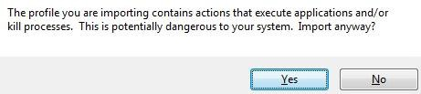

The VAICOM PRO for DCS World profile contains a large number of keywords. At some point you may see a popup with a statement to this effect. Modern PC systems are perfectly capable of handling this without issue; if you see this message simply press OK to confirm.
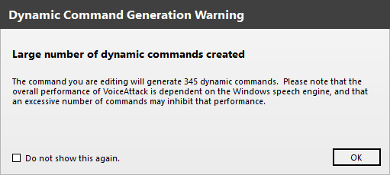

When the Profile initializes you will see a few startup messages in the Voice Attack log window.
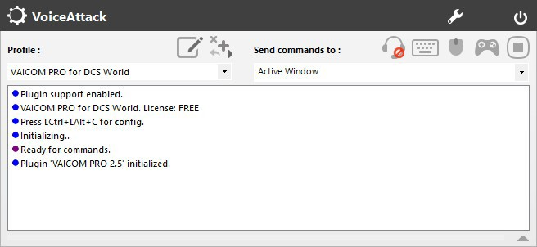

DCS WORLD OPTIONS
VAICOM PRO is designed to automatically work with existing DCS World versions, normally without user configuration needed. The below guidelines apply to all DCS World versions. Start DCS World and check these options in the DCS World configuration section:

HOTAC MIC keys: Decide which keyboard keys and which HOTAS buttons you want to
use with VAICOM PRO for Push-To-Talk functions. Now make sure these keys/buttons used with VAICOM PRO are not used anywhere in DCS config. Specifically, make sure the keys/buttons used with VAICOM PRO PTT are not mapped to HOTAS MIC or Comms Menu functions in DCS config. More on PTT mapping in the next section.
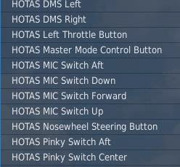

NOTE: The functionality of the plugin is not impacted if these fields are not cleared but it’s highly recommended to clear them to avoid any menus being shown when pressing these buttons, which would spoil an otherwise menu-free experience.

Sound settings: 50%
VAICOM PRO audio is optimized for all audio sliders set to 50% in DCS World configuration (assuming equal levels in Windows audio mixer). Change this if you want relatively louder or softer DCS audio.

Easy Communications: ON or OFF can both be used with VAICOM PRO. The setting is
recognized automatically by the plugin and its behavior changes accordingly.

Subtitles: ON or OFF. For maximum immersion it is recommended to switch subtitles off. However, if you are new to VAICOM PRO and/or testing certain features with pilot voice switched off it can be useful to have visual confirmations by switching subtitles ON in DCS config.

Done for DCS settings. Proceed with Push-to-Talk configuration.

PUSH-TO-TALK SETUP GUIDE

VAICOM PRO uses Push-To-Talk for all voice commands. One of the main things to do for the setup of VAICOM PRO is to think about the push-to-talk configuration you wish to deploy on your system. You can use your HOTAS for this, your keyboard, or a combination.

By default, the PTT and Chatter functions in the profile are mapped to keyboard keys 1-6 and 0, and also to a set of joystick buttons on ‘Joystick 1’ device. However, this is mainly for example purposes and it is recommended to change this to match your own setup and preferences as per below. This section will provide you with the basics for a typical setup and advanced users can take off from there. Note: for advanced PTT setups such as with Simple Radio Standalone (SRS), refer to page 25-26.

Joystick and keyboard mapping in Voice Attack

Consult the Voice Attack manual if you are not yet familiar with basic setting up of keyboard- and joystick shortcuts in Voice Attack, but this is really kind of self-explanatory. For HOTAS use you’ll first need to activate the joystick device you want to use with Push-to-Talk functions in the VA Options window. Use the ‘+’ labels in VA. Then edit the profile to set up your preferred PTT buttons using the ‘TX’ mapping labels.
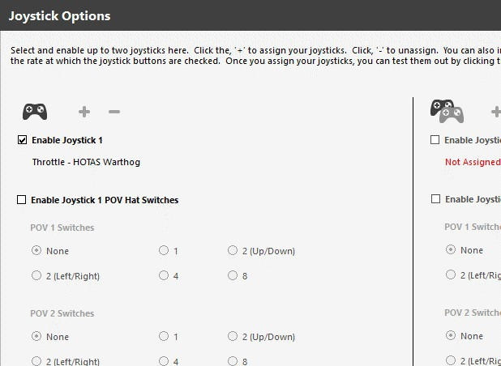
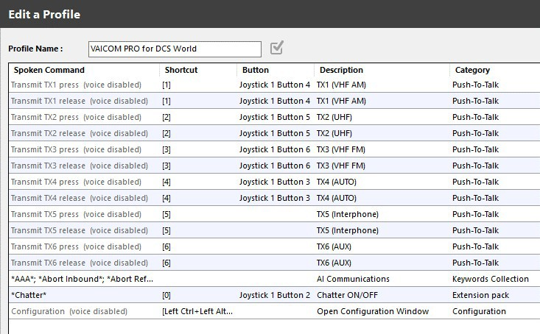

The TX 1-6 mapping system

It is helpful to understand the TX labeling system used by VAICOM PRO. If you inspect the VAICOM PRO Voice Attack profile you will see that there are 6 pairs of commands in the Push-to-Talk category, each with the names referring to ‘TX1’ to ‘TX6’, where each TX pair consists of one ‘press’ and one ‘release’ command. The trick is this: you need to assign each keyboard key or joystick button you want to use for PTT to

- a TX press command, and
- the corresponding TX release command.

Press and release must refer to the same key/button: so you assign each key/button twice.

NOTE: Make sure you get this right for each press/release combo. You’ll notice that the Release commands have this option selected: ‘shortcut is invoked only when all keys/buttons are released’.
Inside the VA profile you can map the Transmit (TX) nodes to your physical keyboard keys and/or HOTAS buttons by editing the ‘Press’ and ‘Release’ commands for each TX. Inside the plugin, the TX1 to TX6 nodes are automatically mapped to the available radios for the active DCS aircraft module during gameplay. So when you map your physical key to a TX node the plugin will use it for push-to- talk with the corresponding aircraft radio:

This auto/mapping for each DCS module is done with a standardized method which enables you to configure just a single generic hardware layout on your rig that you can use with all DCS aircraft for PTT without having to reconfigure each time you switch aircraft type in DCS World. Once set up, things should become really easy.

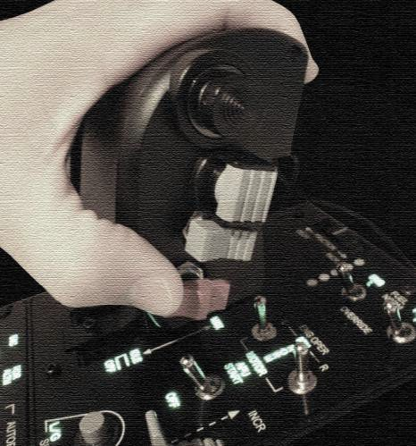

On the left an example PTT layout is shown for the Warthog HOTAS Throttle. The VAICOM PRO plugin always tries to map the available aircraft radio device types according to this logic:

- TX1: ➔ VHF AM
- TX2: ➔ UHF
- TX3: ➔ VHF FM
- TX4: ➔ AUTO
- TX5: ➔ Interphone
- TX6: ➔ AUX (Not in Use)

With that in mind you can see how the button mapping shown here would make sense.

The setup shown here is the recommended generic mapping. This should work across different DCS modules without the need to switch configuration. Using a generic setup like this will allow you to fly with all the various DCS modules with a maximum of ease and consistency.

However, if you only fly specific aircraft you may want to tailor your PTT buttons to just suit those. For some DCS aircraft only a single radio is available (e.g. WWII aircraft). Others may have no FM radio or a combined UHF/AM stack etc. So for each DCS module the PTT/radio mapping layout will look slightly different. This can be checked in the PTT page of the Configuration Window. If you want a tailored setup, use the PTT page and TX labels to guide you with the appropriate mapping that will work best for your situation.

In the shown example the center push button is used to toggle chatter (CHTR) on/off, useful only if the Chatter Themes extension pack is installed. If you do not use chatter you could use the center button for e.g. a separate Interphone function by mapping it to TX5. Up to your preference.

More on PTT mapping
The PTT details can be viewed in the PTT page of the plugin configuration window while DCS is running. Press LCtrl+LAlt+C to open the Configuration Window. The various functions of this window are described in more detail in the Configuration Window chapter. For now, click on the PTT tab.
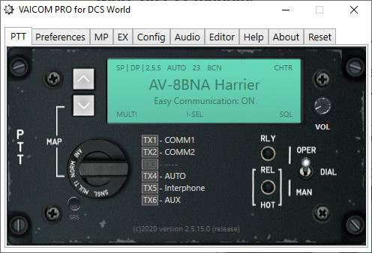

To see all the radio slots, set the PTT Mode selector dial to NORM or MULTI (more on the PTT mode options on page 35).

TX1-TX3:
For DCS aircraft with multiple MIC hotkeys, the plugin maps the available aircraft radios to TX1-TX3. If less than three radios are available for the current aircraft, one or more of these TX nodes will be disabled.

TX4:
This node is reserved for the AUTO function. AUTO automatically uses the correct radio for the called recipient. AUTO is only available when Easy Communication is set to ON. With Easy Communication set to OFF, TX 4 has no function and the node is disabled. If you fly only with Easy Communication OFF or you do not intend to use AUTO, then there is no need to map any key/button to TX4.

TX5:
This node is dedicated to an Interphone key specifically for talking to ground crew. This key is optional since ground crew can also be addressed using any of the other TX1-TX4 or TX6 nodes. TX5 is there to have the possibility of a dedicated Interphone key for advanced setups, but it can be ignored if you want to be more economical.

TX6:
TX6 is also optional. It is currently reserved to be used as a dedicated PTT key for cockpit device control commands. These are not available at time of VAICOM 3.0 plugin release but may come in the form of future expansion pack releases. Also, you can use TX6 as a PTT for your own voice commands if you want to enrich the Voice Attack profile with some of your own commands which use VA’s standard method of sending virtual keypresses. If you feel no need for this, you can disregard TX6 for your setup. Always use TX6 with your own commands if you want to use the plugin’s Exposed Variables.

USING VAICOM PRO

HOW IT WORKS (IN A NUTSHELL

Speech recognition
VAICOM PRO uses Voice Attack to interface with Microsoft Windows Speech Recognition. Primary language support is English (US/UK). However translated dictionaries can also be used with other MSWSR languages such as French, Spanish, German,... The engine can be trained with your voice for improved recognition, see Training Mode section. Push-to-Talk must be used always in combination with VAICOM PRO PTT as described in the PTT setup section. Commands will not work without PTT.

Keyword-based interpretation
VAICOM PRO uses dynamic keyword-based speech interpretation. This means you have a great amount of flexibility in the way you phrase your command. From the extracted keywords you use in your spoken sentences VAICOM PRO derives which message to send, with which parameters, and to which specific recipient. VAICOM PRO has an internal commands- and recipients database which can be referenced by one or more voice command phrases (or ‘aliases’). In the keyword editor you can tweak and manipulate these voice command phrases in detail if needed.

Dynamic state picture
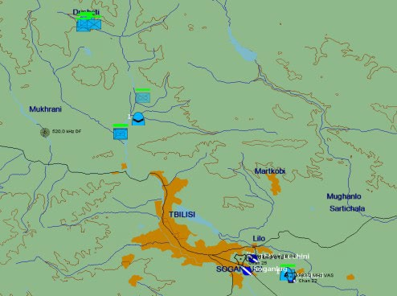
At mission time VAICOM PRO dynamically maintains an active state ‘picture’ of the current mission environment. Triggered by PTT it continuously requests and receives mission data updates from the DCS World simulation.
This data exchange is based on sending and receiving JSON objects over UDP network protocol. Amongst other things this approach makes it possible to run VAICOM PRO and DCS on different machines connected over a local network.

Data exchange is real-time and so there exists effectively a sync-lock between DCS and the VAICOM PRO plugin at all times. The comms menu system is not used an neither are DirectX keys. Instead, VAICOM PRO talks with the finite state machine /event core engine of DCS directly. This ensures a 100% integrated system where any flow sync issues are excluded by definition.

You can think of the State as a virtual map of the environment where all relevant AI units are mapped onto. VAICOM PRO is aware of all the addressable AI units in the area each with a unique ID, callsign, range and status. When a radio message is sent by VAICOM PRO, it targets the message at a specific AI unit i.e. the one you selected. This means that something like shifting menu positions or contents (a problem that cannot be tackled with vanilla Voice Attack using just keypresses) are no longer relevant and cannot interfere with your conversations. There is a wealth of other advantages to this advanced real-time system.

USING PUSH-TO-TALK
All voice communications must take place using one of the six available push-to-talk nodes (TX1 -TX6). Each TX node refers to a specific radio. Depending on the radio configuration of your current aircraft some TX nodes may be inactive. You can check this in the PTT page from the Configuration Window. When you press and release an active PTT key you hear a short burst of static noise. You can start speaking right away and when recognized the command will execute immediately. You can release PTT immediately after you finished speaking i.e. just as in real life.


Note: Commands are executed immediately and you can release PTT almost immediately, hold for another 0,5 second after you finish your voice command.

Note: Also, you may hold the PTT after the command was executed and issue a next one. This will be executed without the need to first release and press the PTT key. Again, as in real life.

Note: Advanced PTT setups including dynamic switching for human communication such as Voice Chat and Simple Radio Standalone are covered on page 25-26.

DEFAULT SPEECH PROCESSING MODE: THE MICROPAUSE
Note: Below applies only to the default speech processing model! Not for VSPX processing.

This is important especially for beginning users: apart from speaking slowly and well-articulated to improve your recognition rates, carefully observe the following. When issuing your voice commands, leave small (0,5 sec) pauses between the recipient and the command phrase. This takes some getting used to but becomes second nature in no time. Especially in the beginning leave a short silence in between like for example in ‘Darkstar, ...Request Picture.” This will help the recognition engine to better catch on to what you’re saying. Once you get this rhythm it’s easy. Your recognition rates will increase rapidly. After a while (when the engine is better trained) you can speed this up a bit.

Note: As a timing aid: if in Preferences you have enabled the option ‘use audio hints’, you will hear a short soft blip when the recipient was recognized after which you can continue with completing the voice command.

THE BEEPS
The UI audio feedback system of VAICOM PRO consists of a limited set of standardized sounds which provides you with useful information during gameplay. The following UI sounds are used:

- Confirmation (beep)
- Awaiting additional input (blip)
- Recipient not available (click)
- Error (thud)
- Ambiguous (flat beep)
In the configuration window there is the option to switch off the UI sounds if you feel you don’t need them (sure about that?). Some sounds also relate to the Use Audio Hints setting in Preferences.

OPTION: VSPX SPEECH PROCESSING
As an alternative to VAICOM’s default speech processing mode, VSPX speech processing can be selected in Preferences. VAICOM’s Single Pass Extraction mode provides a faster interpretation model for processing spoken sentences than the default model used by VAICOM to handle speech content.

Note: VAICOM’s interpretation module is independent of any desktop language or MS Speech recognition engine used: it is specifically tailored for DCS and deals with the order and context of keywords in relation to module radio settings to assess the correct command- and message actions to be deployed in the sim core. You can use VSPX with any language.

Using VSPX or not can be a matter of personal preference on which model suits you best. Models can be switched between with just a few steps, see below. It is recommended to work with the default processing model first and try out VSPX later to get a feel for the differences.

The main differences between VSPX and default processing are as follows:

- VSPX is tailored for fast speakers: if you like to blurt things into the mic instead of slowly articulating: VSPX may well be the thing for you.
- VSPX does NOT use the micropause between recipient and command. On the contrary, sentences must be spoken in one go. Do not wait for any blips. Hurry up!
- VSPX does not allow use of Sender keywords (see page 55). So instead of default ‘ Darkstar,.. Boar 2-1,… Request Picture’ you’ll just say ‘Darkstar Request Picture’.
- In the keywords editor you will be able to add your own asterisk (*) wildcards at the start and end of command phrases to allow for additional freedom of speech.
- In the keywords editor, you will not get feedback on your VA profile with the TEST button (this may follow in a later plugin update). When in doubt if your VA profile is up-to-date, follow the FINISH steps (see page 37).
- All other workings are equal between the two modes.

Switching Between Modes

To change between Default and VSPX modes, follow these steps:

- In Preferences, (de)select VSPX option: you will see a pop-up. Press OK.
- Follow the FINISH steps in the keywords editor to update your VA profile,
- In Voice Attack options put these settings as follows:

Unrecognized Speech Delay

VSPX OFF: 0ms.
VSPX ON: 600-1000ms: 700ms recommended.
Done. The green light on the editor page shows whether VSPX is activated.

SPECIAL COMMAND: ‘SELECT’
The ‘Select’ special voice command is used to set your conversation to a particular recipient in a category. With Easy Communications ON, this also tunes the radio. With Easy Communications OFF, Select also tunes the radio but only when the ‘Select Tunes Radio’ option is enabled in Preferences. Primarily, Select sets the dialog to a recipient. This means that after you have selected a recipient, any next commands you issue in this recipient category will be directed to the selected recipient unit. All this is actually quite simple in practice and best clarified by some examples.

Easy Communications ON:

Get in a new mission with an A-10C aircraft or similar that starts on the runway ready for departure. Now to see how the Select voice command works with Easy Comms on, manually change the tuning of your UHF radio to some meaningless frequency. Keep watching your radio panel and then on UHF call: ‘Flight,… Select.’ (or ‘Enfield,… Select.’ If that is your current flight group callsign). You’ll notice that the radio frequency automatically switches to that of your flight.

On VHF AM call ‘Soganlug,…Select.’ and watch the frequency change on your VHF AM radio. You are now tuned to Soganlug ATC and ready to have a chat with them. Now if your next call on VHF AM does not mention ‘Soganlug’ keyword but is for example “ATC,.. request vector”, or even simply e.g. ‘inbound’, the call goes to Soganlug since this is the currently selected ATC. All ATC calls go to this recipient now until you switch to another ATC recipient by using Select again.

Easy Communications OFF:

Run the same mission as above but this time with easy comms set to off. You’ll notice that the radios do not get tuned this time, you need to do this manually. However, if you have used the Select command to set your conversation to Soganlug then calling e.g. ‘ATC, ready for departure’ after that calls Soganlug airfield. So it works the same as with Easy Comms ON just without the radio tuning. If (recommended) you enable the option ‘Select Tunes Radio’ however, the radio gets tuned also with Easy Comms off.

Select Nearest

You can use the ‘nearest’ keyword in your voice commands to call or select to the closest unit in the category, e.g. ‘Nearest Airfield,… Directions to Final’ or ‘Nearest Tanker,.. Select’. When you start a new mission, the nearest ATC is selected automatically. This means you can call ‘ATC,…Request Engines Start’ immediately without having to use the Select command first.

Instant Select option

You can make use of the additional Instant Select feature. When this option is switched on, the Select command is no longer needed to switch recipients. Instead, just naming a recipient in your call
e.g. ‘Anapa,…inbound’ switches to Anapa tower immediately. With easy comms ON the radio is automatically tuned for the new recipient. This provides a fast (although perhaps not entirely realistic) means of switching dialog between recipients without the need to involve the Select command at all.

Using Select for manual radio tuning.

Make sure the Radio Control commands are included in your profile (if needed use Config/Export). For DCS modules that support this (not all do), you can use Select for manual radio tuning. Try ‘Select two five zero decimal five’ for 250.500MHz and ‘Select Channel 5’ for Channel selection on compatible radios.

SPECIAL COMMAND: ‘OPTIONS’
When the Options command is enabled in Preferences it can be used to briefly peek at the on-screen menu. To use Options, the ‘Disable Menus’ option in Preferences can be either selected or deselected: Options can be used in either case.

This command is intended primarily for less experienced users who are not (yet) entirely comfortable to fly without menus. The Options voice command (e.g. ‘Vaziani,..Options.’ or ‘AWACS,… Options, etc.) gives you the option to briefly check which commands are available for this recipient at any given time. After inspecting the menu, you can then speak the command phrase you intend to use. Also, for very dynamic flows e.g. JTAC engagement this can be useful as a reminder, since during the various complex stages different commands are appropriate.

Note: Be aware that the Extended command set that can be used by VAICOM PRO contains more commands than those listed in the DCS comms menus! In the end it is advisable to train yourself to use the full VAICOM PRO command set without referring to immersion-breaking menus at all. You can do without them, which is more or less the point of this plugin in the first place :) Practice!

SPECIAL COMMAND: MENU CONTROL
Although use of menus in general is strongly discouraged and not needed when using the plugin, there are still some areas where it can be unavoidable. For this, some specific menu control commands are available. These commands are particularly intended for use with the Descend, Cargo and Other menus but can be used with any on-screen menu. The ‘Take’ command lets you select a particular item from a menu that is shown on screen.

The flow is like this:
- Call e.g. ‘Cargo,.. Options.’ and hold the PTT button. The on-screen menu appears. Say ‘Take 2’ to select the second listed item (i.e. F2).
- For Other menu call ‘ Server,.. Options’ or ‘ Mission,.. Options’. The F10 menu appears.
Say ‘Take 5’ to select the fifth item (F5), etc.

SPECIAL COMMAND: REPLIES
Reply keywords have been added to enliven the conversation. Refer to the Keywords Reference section for a listing. Reply statements are void in function but it makes the interaction more fun and realistic if you can reply to a call with ‘Roger, Wilco, Negative’ etc. as appropriate for the dialog.

CRYSTAL PALACE AOCS: ‘BRIEFING’, ‘STATUS’, ‘INTERROGATE’
As a unique feature, VAICOM PRO makes available AOCS (Air Operations Control Station) - default callsign Crystal Palace: a virtual ground station that provides you with tactical information on coalition units. At any time during a mission (and you having been sloppy during preflight briefing again) you may find yourself wondering whether a particular unit (AWACS unit ‘Darkstar’, say) is actually around in the current mission area. You could issue a random command or open a menu to find out whether the unit is listed there, but a cleaner way (no more menus from now on, remember) is to use the Interrogate or Status voice command for the AOCS ground station to get all the details.
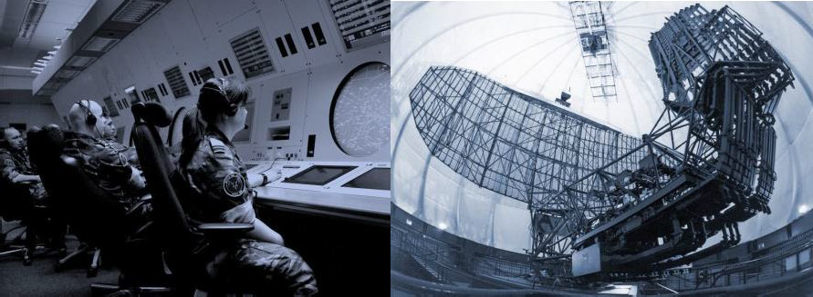

The AOCS command station is located at your ATC of departure. When you use Easy Communications OFF setting, Crystal Palace must be contacted like any other coalition unit i.e. using radio tuning (for Easy Comms ON this is not needed). Its contact frequencies are:

- AM 071.000 MHz
- AM 142.000 MHz
- AM 284.000 MHz
By contacting AOCS you can quickly and conveniently get info on units in the mission without using menus. Useful examples of AOCS calls include:

- ‘Crystal Palace,…Briefing’: AOCS will read out the current mission brief,
- ‘Crystal Palace,…Status’: AOCS will provide a general units overview summary,
- ‘JTAC,…Status’ or ‘Firefly,..Interrogate’: AOCS will provide JTAC ‘deep interrogate’ details. When you call e.g. ‘Darkstar,..Interrogate’, you will hear:
- A confirmation beep if AWACS unit Darkstar is in the area (and a click sound if not),
- Followed by a detailed unit briefing by AOCS, if Deep Interrogate is enabled in preferences.
Deep Interrogate provides very specific unit detail such as range, direction and altitude, as well as the radio frequencies on which to contact specific units. By providing this real-time info dynamically at any time, AOCS can be a valuable asset to any mission.

AOCS is available in both Single Player and Multiplayer modes, for Multiplayer you need to enable it on the MP page. The ‘Crystal Palace’ keyword can be changed in the keywords editor if you prefer to use a different callsign for the AOCS unit.

Note: AOCS makes use of the MS Windows Text-To-Speech engine, make sure it is set up correctly.

GETTING STARTED: FLYING A BASIC MISSION
To train with VAICOM PRO, enter a basic standard single player mission and practice with that first. Once you get the hang of it move on to more demanding stuff. Easy Comms ON is recommended for the initial getting acquainted stages, once that works well move on to Easy Comms OFF. When first practicing you can leave Pilot voice on or (recommended) enable subtitles to get visual confirmation. Switch them off again at your earliest to maximize the immersion factor.

Note: Keep in mind that for e.g. WWII-era aircraft with basic radio systems typically only a small number of preset frequencies can be used. These frequencies are set by the mission designer. You can only reach recipients that match these pre-programmed radio frequencies. The same goes for example for using JTAC. You can engage with JTAC from any aircraft, but the JTAC frequency/ modulation type set in the mission editor must be suitable to be tuned by the aircraft radio system.

The following assumes A-10C aircraft but you can use any other module as well for this.

On the Ground

Test ground crew communications when standing still on the ramp or runway. To try out, press and hold the TX1 | VHF AM or TX5 | Interphone hotkey and call "Chief, Ground Power Off". Wait for crew response. When you try to call Crew when airborne you will hear a ‘Recipient N/A’ click sound.

ATC

When the mission starts your radio will be tuned to the nearest airfield automatically. So, when on the ramp you can start immediately by calling ‘ATC, Request Engines Start’ on VHF AM. Request taxi to runway and when lined up call ‘Ready for Departure”.

Flight: Formation and Maneuvers

Once airborne fly around in circles and have your wingman change formation. Note that you can address your wingman directly for formation calls, e.g. "Two, Go Trail" will be executed by your wingman, instead of having to call "Flight, Go Trail" (which works also). This is appropriate for two- ship formations. As fun feature you can also use your virtual buddy’s callsigns when calling flight members: e.g. call “Gopher, break right” to have your wingman 2 exit formation. If your group current callsign is e.g. Uzi you can use it to address your flight e.g. call ‘Uzi, Go Spread Four’ instead of the generic ‘Flight, Go Spread Four’.

Flight: Engage

Have your wingman attack some ground targets. A line like "Two... engage ground targets from the East with Mavericks" is said in one go. Do not wait for any menus to appear while you issue your commands! You can use the word ordering in this example (i.e. direction before weapon directive), since VAICOM PRO will interpret the phrase contents automatically based on keywords and will send out the correct command to DCS accordingly. Wait for wingman’s reply.
Also, you can be looser in your formulations e.g. a line like ‘Two... take out that Triple A with Guns’ will be understood by VAICOM PRO. Experiment a bit with loose formulations throwing in the appropriate keywords. Call "Two... rejoin" after you've seen enough action.

AWACS, Tanker, ...

Call “AWACS,.. Options” to see available AWACS commands (hold the PTT key). Call AWACS on VHF AM for example with "Wizard, Colt 11, Request Picture". For a tanker approach with ‘Texaco, Chevy 22, Approaching for Refuel’ and continue from there.

JTAC

JTAC communications are the most interactive in DCS World, going through various stages. There’s a wide range of commands available for Type1/2/3 attacks with smoke, Laser, and IR target designation scenarios. The VAICOM PRO keywords set includes several JTAC commands which are not listed in the menus. As a unique feature VAICOM PRO allows JTAC engagement with all aircraft types including helicopters. This is something that cannot be done with the communications menu system and opens up a whole new spectrum of engagement scenarios for DCS World. The Extended Command set must be activated for this in Preferences.

Refer to the Keywords Reference section and read the separate section on JTAC flows. Do not rush your JTAC training. Dynamic JTAC engagement dialogs are complex and take practice but are also in the end amongst the most rewarding.

ADVANCED USAGE

Importing F10 Menus

Some missions make use of the ‘Other’(F10) menu for special commands. If in Preferences the option ‘Import F10 Menus’ is enabled the F10 menu items will be added to the keyword database. The imported keywords cannot be used immediately, the updated keywords list must first be added to the VA profile. See Keywords Editor section in the Configuration Window chapter.

Importing new Theaters

The plugin is prepared to deal with new DCS Theater releases. If the ‘Import new Theater’ option is enabled the plugin will scan for new ATCs on mission start and add them as recipients to the database. After import is done you need to reload the database in the Keywords Editor and then paste the updated keywords list in the Voice Attack profile. Refer to the Keywords Editor section in the Configuration Window chapter.

Importing new Modules

If the ‘import new modules’ option is enabled in Preferences you can fly with a new module and it will be added to VAICOM PRO’s database without additional action required. Useful for e.g. Early Access releases that are not yet on the VAICOM PRO list of supported modules.

MULTIPLAYER

ABOUT MULTIPLAYER
VAICOM PRO is fully compatible with Multiplayer and has an advanced feature set for MP-specific use. In Preferences you can enable the ‘Use with Multiplayer’ option which allows you to use VAICOM PRO in the same way in Multiplayer mode as with Single Player mode. The plugin maintains a state picture of the mission environment provided by the multiplayer server. The addressable AI units are available for communications in the same manner as with Single Player in as far as mission design is compatible with standard functions.

Prerequisites

For working with Multiplayer, on the MP page the ‘Use with Multiplayer’ setting must be enabled. On the MP server, the setting Allow Player Export must be enabled.

MP Server Special Menus

Through the ‘Import F10 Menus’ function it is possible to add server-specific commands to the voice commands set. Imported F10 menu items get ‘Action’ in front of the phrase: for example an imported menu item ‘Push to Waypoint 2’ would become ‘Action Push to Waypoint 2‘ on import. This can then become anything you like in the keywords editor. This import will only work if the server has implemented the F10 menu in the standard compatible manner (which is the case for most servers).

MP limitations

Multiplayer mission designers can take great liberties in mission design, e.g. by introducing custom callsigns, custom menus and all kinds of other tweaks outside of the default spectrum. VAICOM PRO cannot support these by default. Where the mission design makes use of the standard features, VAICOM PRO will support them. But some limitations may apply on some specific servers. Nevertheless, VAICOM has a comprehensive toolset built-in to do complete dynamic AI comms in Multiplayer mode, working in mostly the same manner as in Single Player.

VOIP INTEGRATIONS

On Mixed AI/Human Environments

Multiplayer theaters typically consist of a large number of coalition units populated by both AI and human players. In this multiplayer area, VAICOM PRO does not provide the human-to-human communications: for this various other VoIP tools are available that can be used in parallel with VAICOM PRO. VAICOM PRO is used for AI communications, and ideally all these tools share a common framework so that DCS users can have a unified comms experience. With the latest plugin version this goal has come one step closer.

Specifically, DCS Simple Radio Standalone (2.0.7.0 and higher) and Eagle Dynamics’ Voice Chat VoIP feature are now integrated with VAICOM PRO. This means that users can have a single TX setup for VAICOM and VC/SRS sharing the same set of PTT keys/buttons, where VAICOM PRO controls the mic
states for the VoIP tools as required. The aim is that in the end VAICOM PRO users will have a seamless and realistic communications experience in a complex dynamic DCS World multiplayer environment with a relatively simple setup by using VAICOM PRO.

Why use VoIP integrations

In a multiplayer environment, your radio can be tuned to frequencies that are not used at all, to channels that are populated with human players, populated with AI units, and/or to channels with a mix of both recipient types. The ideal setup deals with all these scenarios.

In the most simplistic view, you could assign a set of buttons that trigger both VAICOM TX nodes and VC/SRS push-to-talk for the corresponding radios at the same time. And indeed, this is the most realistic in principle: if you then press a PTT button, your mic audio is sent to both humans via SRS and, in parallel to VAICOM / speech recognition engine. However, there are a few snags to address here especially for comms on mixed-population channels:

- If the speech recognition engine is exposed to stuff you’re saying to other human players,
it will try to make sense of it, setting off incidental triggers leading to all kinds of mismatches and potential erroneous commands sent to random AI units. This gets messy easily and should be avoided. So ideally the speech engine does not listen to you when you’re talking to humans.
- At the same time, you may not want your human fellow players hear you talking to AI (although that would actually be the most realistic experience). Depending on how confident and experienced you are, there can be good reasons you may want to have your Bogey Dope exchanges with the AI AWACS unit shielded from your human-to-human communications on the same frequency.
The plugin integrations with both Voice Chat and SRS take the above into account.

VoIP integration modes

VAICOM PRO remote controls the microphone listening states for Voice Attack as well as SRS and Voice Chat dynamically, based on the preferences set on the MP page under the VOIP CONTROL header. There are three independent VoIP integration modes, selectable by the slider:
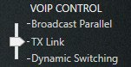

- Broadcast Parallel is the simplest mode, where mic audio its transmitted to both AI (speech recognition) and humans (VoIP) at the same time, using standard TX press-and-hold.
- TX Link allows use of different types of Push-To-Talk, i.e. short-press for transmit to AI (speech recognition) and press-and-hold for transmission to humans (VoIP). Important: if you plan to use this advanced hybrid mode you need to adjust your VA profile, see below.
- Dynamic Switching uses regular Press-And-Hold to start transmitting to AI (speech recognition), after which the transmission can be switched to VoIP while holding.

Setting up VoIP clients

Start by configuring the clients you want VAICOM to control.

Note: these settings for VC and SRS apply in the same way for all integration modes.

Setting up Voice Chat

Enable the option Voice Chat Integration on the MP tab. VAICOM PRO will now automatically control the mic listening state for Voice Chat in multiplayer mode. No additional action is required.

Setting up DCS-Simple Radio (SRS)

Enable option SRS Integration on the MP tab and select SRS PTT Mapping (optional, recommended). The recommended SRS Client setup for use with VAICOM goes like this:

- (SRS Controls Page) Set the same buttons/keys for Radio 1-3 that you use for TX 1-3.
- (SRS Settings Page) Radio Switch works as Push To Talk (PTT): ON
- (SRS Settings Page) Allow INCOCKPIT DCS Controlled PTT: OFF.
- (SRS Settings Page) Allow VAICOM TX Inhibit: ON.
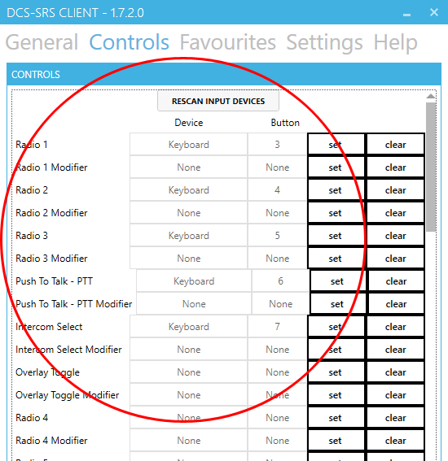
VAICOM PRO now controls SRS Client mic states using one of the three integration modes.

Note: SRS can be tested with in Single Player mode: start SRS server on your desktop and have the SRS client connect to address 127.0.0.1. Then fly a Single Player mission.

Note: integration does not apply for SRS Expansion / AWACS radios.

Note: SRS PTT mapping is independent of SRS integration and can be enabled anytime.
This setting makes sure that radios are assigned to the TX nodes in the same slots as in SRS. Although not strictly necessary, if you use SRS in parallel with VAICOM PRO it is recommended to enable SRS PTT Mapping.

Credits to @Ciribob and the SRS team!

Setting up plugin VoIP integration modes

Below are instructions for using the three different modes. It is recommended to choose a preferred mode and then use this throughout. During testing observe the various mic state indicators




XMIT (LCD): Transmission active
RLY: Mic audio relayed to VoIP (VC/SRS)
REL HOT: Mic audio transmitted to speech recognition after TX release PHONES: Mic audio transmitted to speech recognition

Sound notification can optionally be enabled (recommended) to signal when VoIP transmit is active.

Broadcast Parallel

When Broadcast Parallel is selected, all your transmissions and commands will be audible for your fellow player using VC/SRS on the same frequency. This is the most realistic mode, and no additional configuration is required. Use with press-and-hold on any TX.

TX Link

TX Link mode allows to differentiate between short-press PTT for transmission to AI (speech recognition) and press-and-hold for transmission to humans (VoIP). Optionally apply the MP Only checkbox to use this behavior only in Multiplayer, with normal PTT in Single Player mode.

Note: Using the TX Link option requires editing of the VAICOM PRO for DCS World profile in Voice Attack and is recommended for advanced users only. Although below configuration steps are not difficult, they must be executed with care, as improper VA profile configuration will impact normal PTT functioning. Reminder: a fresh default .vap profile file can always be retrieved for reference by using the Export button on the Config tab.

Carefully apply the below settings to configure Voice Attack for use with the TX Link option. In the VA profile, edit the TX Press and corresponding TX Release commands. Notice that in non-TX Link profile configuration, the ‘long-pressed’ checkboxes are not selected. For using TX Link you will be selecting these checkboxes. They need to look exactly as follows for all TX 1-6

TX PRESS: TX RELEASE:
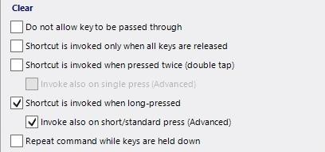
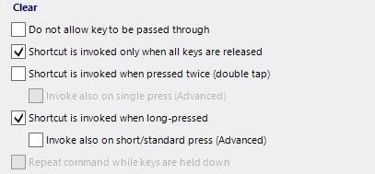
Enable SRS Integration and/or Voice Chat Integration options on the MP tab. The settings in SRS Client must be as described above on page 26. Next, in Voice Attack options / Hotkeys tab, set all long press threshold values to 100-300ms (depending on hardware):

When flying an MP mission, you can now use the TX nodes in the following ways:
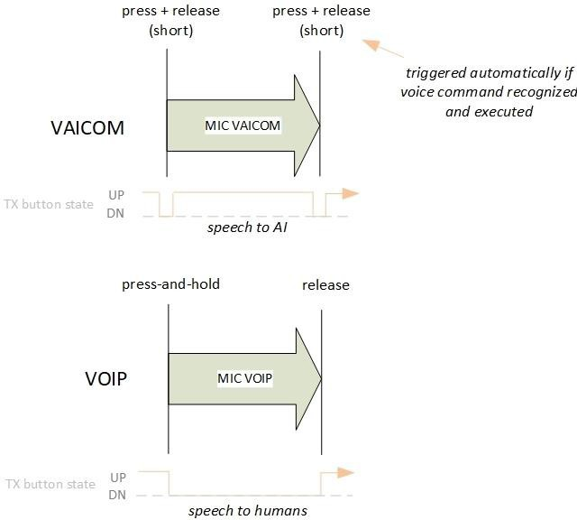

Transmissions to AI are not heard by human players and speech recognition is disabled while talking to humans via VoIP. This allows for an efficient setup using standard TX nodes during MP sessions without assigning any separate dedicated buttons/keys to e.g. SRS.

Dynamic Switching

Lastly, Dynamic Switching can be selected, which gives granular control over VoIP transmission behavior. The selection boxes for Dynamic Switching are explained on MP Settings page 31.

To test dynamic switching mode, enable Auto Switch and Hold AI Transmission. In a random mission call e.g. ‘ATC,… Request Vector’, and keep holding the PTT button after you have finished your command to the AI unit. You hear the beep and now see the RLY light automatically switch on: VoIP is activated and as long as you keep holding the TX key you can speak to your human teammates (e.g. say ATC request vector again but this time using your team-agreed brevity code). When you release the PTT key, the transmission ends, and the command is sent to the AI ATC unit. Switching can also be done ‘manually’ by invoking the ’Switch’ voice command.

THE CONFIGURATION WINDOW

Press LCtrl+LAlt+C to open the plugin configuration window. For this to work the VAICOM PRO for DCS World profile must be loaded and VA’s keyboard shortcuts must be on (look for a keyboard icon).

The configuration window has several tabs to control settings and configuration options. Almost all options can be activated and deactivated on the fly and in real time. Unless stated otherwise there is no need to restart VAICOM PRO or DCS World to apply the changed settings.

The Vaicom Configuration Window will use Windows Dark Mode if that option has been selected in the Voice Attack options UI. If Dark Mode is activated in Voice Attack with the Vaicom window open you will need to close and re-open the vaicom window for changes to take effect.

ABOUT PAGE
This displays the current VAICOM PRO Community Release.
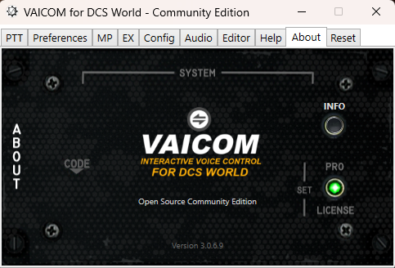

PREFERENCES PAGE
The Preferences page allows you to select/deselect a number of options.
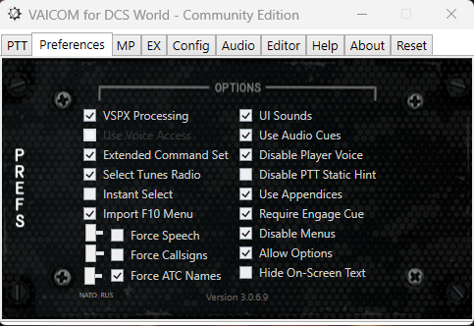
- VSPX Processing: Enables single pass speech processing mode, see page 17.
- Use Voice Access: Use Windows Voice Access for keyword training instead of Windows Voice Recognition (Disabled for now)
- Extended command set: VAICOM PRO has a wider set of commands available then those shown in the standard communications menus. Also, VAICOM PRO allows for cross-module command usage so that for example JTAC is available across all aircraft. To make use of the enriched command set, select this option. Refer to the Keywords Reference section for details.
- Select Tunes Radio: The Select voice command tunes the radio for the called recipient. With this option enabled not only when Easy Comms is ON but also when OFF.
- Instant Select: For Easy Communications ON: the ‘Select’ voice command is used to lock a conversation to a specific AI recipient in a category (see chapter: Using VAICOM PRO). When selecting the Use Instant Select option, mentioning a recipient name in your voice command is sufficient to switch the default recipient in the category to this recipient immediately without using the Select voice command. When the option is deselected, the Select voice command must be used to switch to a recipient.
- Import F10 Menu: adds mission F10 (Other) menu items to the keywords database. Enable this option and fly the mission: items are added as new keywords starting with ‘Action’. Go to the Keywords Editor and follow the FINISH steps to update the VA profile to use the new voice commands: using an imported keyword will execute the menu item command.
- Force Speech: enable to force the speech language across all modules/coalitions e.g. for all communications in English even when flying Russian aircraft or vice versa.
- Force Callsigns: enable this setting to use NATO-style callsigns (‘Springfield’) or Russia /Numeric- style callsigns (‘100’) at all times.

- Force ATC Names: some Russian-built modules such as the KA-50 use alternative ATC naming for the Caucasus / Black Sea theatre. These alternative names are not part of the VAICOM PRO default keyword set (If they must, PRO users can add these themselves in the Keyword Editor). For uniformity (recommended) enable this setting to use standard NATO ATC naming across all modules. The feature is set to ON by default.

- UI sounds: deselect to switch off the VAICOM confirmation beep sounds. Feedback will be absent: recommended only for advanced users.
- Use Audio Hints: switch on for additional audio feedback, e.g. a sound will inform you when you try to call a non-available recipient or when you use the wrong radio (with Easy Comms ON).
- Disable Player Voice: when selected the in-game pilot voice is silenced so you do not hear repeated what you just said yourself. Highly recommended for a realistic experience.
- Disable PTT Static Hint: remove the PTT noise that indicates Vaicom is transmitting.
- Use Appendices: when selected, Engage commands can be further specified by additional directives for use of weapons and attack direction, as in ‘Two, engage artillery with guns from the east’. When deselected, appendices are ignored.
- Require Engage cue: when selected, an engage cue like ‘Engage’, ‘Attack’, ‘Strike’... must be used in your voice command to issue an engage target command to your flight members. When deselected, just mentioning a target (e.g. ‘air defences’) in your sentence is sufficient. The option is set to ON by default.
- Disable Menus: when selected, all on-screen communications menus are set to invisible. You can no longer see or use the menus (except by using the Options command). Recommended for advanced users seeking maximum immersion and realism.
- Allow Options: when selected, the ‘Options’ voice command can be used to show the on-screen communications menu for a recipient. This can be helpful e.g. for less advanced users to see which commands are available at any given time during a mission. Recommended to disable for advanced users. Note: more commands are available than visible in the menus. Note: The Options command can also be used when the Disable Menus option has been selected.
- Hide On-Screen Text: (requires DCS restart) will keep a clear screen, i.e. no on-screen text briefings and messages will be shown. Recommended for a realistic simulation experience.

MP PAGE (MULTIPLAYER)
On this tab you find preference settings for multiplayer mode.
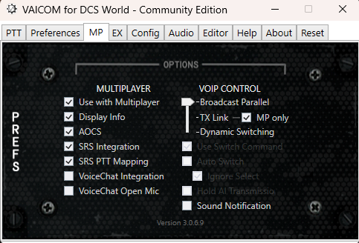

- Use with Multiplayer: enables or disables VAICOM PRO functions when DCS World is running in multiplayer mode.
- Display Info: shows on-screen info about human players on the selected frequency.
- AOCS: have Crystal Palace AOCS unit available also in multiplayer mode to provide dynamic updates about coalition units.
- SRS Integration: allows VAICOM PRO to automatically control SRS mic listening states
- SRS PTT mapping: maps the TX slots according to the radio layout used by Simple Radio Standalone. This is recommended whenever SRS is used together with VAICOM PRO.
- Voice Chat Integration: allows VAICOM PRO to control Voice Chat mic listening states.
- Voice Chat Open Mic: sets Voice Chat mic in a permanent listen state regardless of PTT use.
- VoIP Control Mode slider: Transmit simultaneously or use wither the advanced TX Link option for combined Push-To-Talk or Dynamic Switching mode (see page 26).
- Use Switch Command: allows manual switching to VoIP. Keep holding PTT (e.g. after you’ve sent a message to an AI unit) and say ‘Switch’: VoIP transmission will be switched on and you can now speak to human player using VC/SRS until you release your PTT key.
- Auto Switch: Keep holding the PTT key after the AI command is recognized.
VoIP transmission will be automatically switched on; you can speak with human players on the frequency until PTT key is released.
- Ignore Select: No auto-switching is performed after executing a Select command.
- Hold AI Transmission: Instead of immediate transmission, the message to AI is not transmitted until the PTT key is released. This generally results in better-timed AI unit responses in a multiplayer environment when using Switch / Auto Switch.
- Sound Notification: A notification sound is played if mic audio is audible to human players on VoIP i.e. via SRS or Voice Chat.

EX PAGE (EXPANSIONS)
On this tab you find preference settings for various plugin extensions.
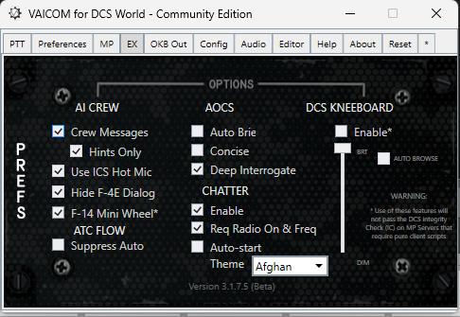

AI CREW
- Crew Messages Displays on-screen call confirmations and options / hints for supported Ai Crewmember voice commands.
- Hints Only Displays messages only for incomplete commands: hints for correct voice command usage are shown on-screen and any unusual intentional controls.
- Use ICS HOT MIC Must be set inside the aircrafts cockpit to enable/disable intercom hot mic.
Note: Overall recognition may be less reliable when using open mic.
- Hide F-4E Dialog Removes the Jester 2.0 contextual dialog in the F-4E.
- F-14 Mini Wheel Provides a custom Jester wheel for a less cluttered UI. (Caution - Breaks the IC in multiplayer for servers that require pure client scripts)

Realistic ATC
- Suppress Auto No automatic pilot messages are generated by the sim, requires a call to progress the ATC flow.

AOCS Setting for the Air Operations Control Station extension.
- Auto Brief: Automatically reads the briefing at the start of a new mission.
- Concise: Reads only the mission briefing summary.
- Deep Interrogate: (SP only) AOCS provides detailed units data w/ range bearing altitudes.

CHATTER Setting for the Chatter Themes extension pack:
- Enable Disabling or enabling the Chatter extension (hot switchable).
- Auto start: Starts background chatter sounds when module connects or if Req Radio On & Freq is checked when the correct frequency is tuned on any UHF radio.
- Req Radio On & Freq: Mutes chatter when radio is off or is on and not tuned to 281.0. Detuning and tuning the required frequency now mutes and unmutes Chatter.
- Theme: Choose an available theme. Note AUTO sets the theme based on the aircraft module.

KNEE
- Enable Disabling or enabling the Kneeboard extension requires a restart of both VA and DCS.
- Slider: Sets the kneeboard transparency in Display mode. Has no effect in VR mode.
- Auto Browse: Automatically selects the appropriate category tab when a recipient is called (i.e. when awaiting additional input).

OKB OUT PAGE

The OpenKneeboard OUT configuration page lets you control the vaicom OpenKneeboard OUT connection and Tab browsing.

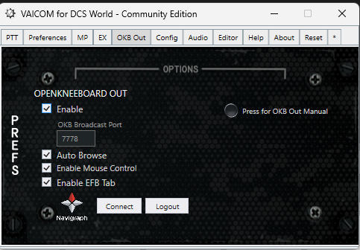
- OKB Out: Enables OpenKneeboard OUT and starts web dashboard. (Also creates Vaicom OKB Out plugin for OpenKneeboard.)
- Port: Changes OpenKneeboard OUT broadcast port number and refreshes plugin.
- Auto Browse: Allows the use of voice commands and auto selects tabs in OpenKneeboard OUT to match the keywords used.
- Enable Mouse Control: Allows the use of addition context commands to switch focus between Openkeeboard and DCS (warning without Focus DCS aircraft cannot be controlled)
- Enable EFB Tab: Adds an Electronic Flight Bag tab to the OKB Out tabs. Allowing user charts for airports and Adds a Moving Map tab with many tactical overlays (see OKB Out help documentation).
- Navigraph Connect: Use Device flow to connect OKB Out to you Navigraph account and enjoy access to you Navigraph charts and high-end Moving Map raster charts.
- Press for OKB Out Manual: opens a dedicated Open Kneeboard Out HTML manual in your browser.

CONFIGURATION PAGE
The Configuration page sets the details for your local PC setup.
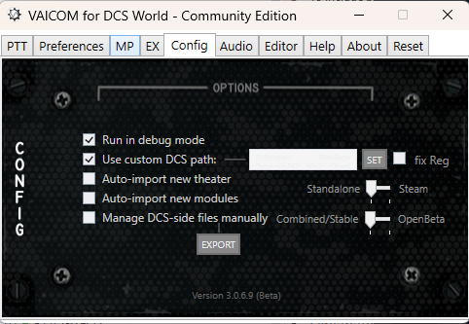

- Run in debug mode: provides additional details in the Voice Attack log window during gameplay and creates a logfile in the Logs subfolder. Recommended to switch this on when trying to track a reproducible problem for support purposes. Otherwise leave off.
- Auto-import new theatres: when enabled VAICOM PRO scans for new ATCs and adds them to the keyword database. Once they are added and the VA profile is updated with the new keywords, the new airfields can be used with VAICOM PRO as recipient units.
- Use custom DCS path: The plugin scans Windows registry for DCS World installation paths on startup. A custom path can be set here to indicate where a DCS World program folder is located. (note: this is your DCS World root folder not the location of the .exe) When this option is selected, the auto-installation routine on plugin startup will use this path and install the required lua code in the selected folder. First, use the sliders to select the DCS World version, i.e. release or open beta and standalone or steam. For DCS standalone versions, the install paths stored in Windows Registry are sometimes not correct, which can lead to a non-functioning plugin. Optionally you can correct the registry by ticking the ‘fix reg’ checkbox. Press SET to browse to your DCS World program files folder (example see screenshot). Lastly, restart VA and DCS.
- Auto-import new modules: With this option selected, VAICOM will automatically add unknown new modules to its database.
- Manage DCS-side files manually: Select this option if you want to manually install files.

PTT PAGE (PRESS TO TALK)
The Push-To-Talk radio mapping page can be used to view the assigned hotkeys for the various aircraft radios. Since the available radio config is different for each DCS module, the PTT setup will be different for each aircraft.

Main Display: The LCD display will inform you about the active aircraft module and whether this module has a single physical MIC hotkey for the pilot to operate or multiple. By selecting the PTT mode selector dial, different PTT mapping modes can be applied to suit your setup. The display also shows whether the Easy Communication setting is set to ON or OFF, along with some additional info. Use the Up and Down buttons next to the display to choose which TX node you want to use for single-hotkey PTT (see below). If no module is detected None Detected is displayed.
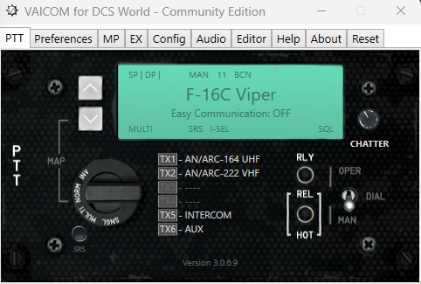

  - PTT Mode Selector: Use the selector dial to choose one of four available PTT modes:

    - NORM (default): This is the standard PTT mapping, aircraft modules with multiple physical MIC hotkeys in the aircraft will use multiple TX nodes. Aircraft with just a single MIC hotkey will use a single TX node: select which one with the Up/Down buttons.
    - MULTI: Use this PTT mode if you want to use separate hotkeys for all aircraft radios, including for modules with just a single physical MIC hotkey in the actual plane (such as most helos and WWII aircraft). On the display, the ‘S2M’ (Single-to-Multi) bug lights up to indicate singles are now mapped to a multi-PTT layout.
    - SNGL: Select this mode if you prefer to have just a single PTT hotkey in your setup for all aircraft. Modules with multiple PTT hotkeys will now be mapped to a single TX node. Use the Up/Down buttons to select which TX to use. The ‘M2S’ (Multi-to-Single) bug lights up.
    - INV: Both S2M and M2S light up in the Inverse mode, signalling that all single hotkey modules are mapped to multiple TXs, and all multiple hotkeys mapped to a single TX node.
  - TX1-TX6 listing: In the Voice Attack profile you determine which physical keys or HOTAS buttons you want assign to TX1-TX6. Consult the section PTT Configuration for details on this. VAICOM PRO automatically maps the available set radio of radio devices of the active module to TX1-TX6 by applying a standardized logic as follows:
- If the module has multiple radios and a VHF AM radio is available, it is mapped to TX1. This radio is typically used for recipients like AWACS, ATC, Tankers, etc.
- If a UHF radio is available it is mapped to TX2. Also, when there is only a single radio available (e.g. as often with WWII fighters) it is mapped to TX2.
- If the module has multiple radios and a VHF FM radio is available, it is mapped to TX3. For example, JTAC communications are typically done over VHF FM radio.
- When Easy Communications is enabled in DCS options, the AUTO option is available on TX4. This PTT key automatically uses the correct radio for the intended recipient. When Easy Communications if off this key is disabled.
- Ground Crew can be contacted over the dedicated Interphone key on TX5. This uses the onboard intercom button. Ground Crew can also be contacted using any of the other TX keys however, so use of this key is optional.
- The AUX function on TX6 can be used for non-radio communications functions e.g. for non-VAICOM PRO commands that you added yourself. Future extension may use this node also.
If a radio slot is not used this is indicated by ‘ ’ and the PTT key is disabled.

  - Operate Dial switch: Used for special cases. Several aircraft (specifically, helos) with a single MIC hotkey have a radio selector dial to select the radio to be used. When easy communications is ON the selector dial is always operated automatically by VAICOM PRO. This option determines whether VAICOM PRO also operates this dial automatically (OPER) or not (MAN) when Easy Communication is set to OFF.
Note: Most (e.g. UH-1H) but not all modules show the dial moving when this function is used. But even when not visible the function works in all cases.
  - SRS PTT mapping: the button next to the PTT Mode Selector Dial switches between default PTT radio slots assignment or Simple Radio Standalone (SRS) – compatible mapping. When SRS PTT mode is selected, the module radios are assigned to TX slots in the same order as in SRS. This means that TX1 always corresponds to SRS radio 1, TX 2 to SRS radio 2 and TX 3 to SRS radio 3. This way a universal multiplayer-compatible setup can be achieved if desired, with SRS and VAICOM PRO sharing the same PTT keys.
  - VOL: set the volume of background chatter.
  - RELAY LIGHT: the light will notify when in multiplayer mode voice speech is forwarded to human players on SRS/Voice Chat. See pages 23-26.
  - Hot Release button: May be applied when VAICOM PRO is used in combination with additional (daisy-chained) profiles in Voice Attack e.g. containing commands for cockpit control. Selecting Release Hot keeps Voice Attack in listening state (hot mic) after TX keys are released. Non-VAICOM PRO commands can then be used without PTT.
All VAICOM PRO communications commands still require PTT to be used.
Note: Trying to use a VAICOM PRO command in Release Hot mode without pressing PTT will generate a (harmless) red log message stating ‘the command is not available in this session’.

AUDIO PAGE
The Audio tab is used to control the settings related to sound redirection. VAICOM sounds such as PTT squelch, AOCS and chatter can be sent to a specific audio device.

Note: ADJ / PAN SELECTORS are no longer functioning with DCS 2.5.6 onwards and these are now permanently greyed out. Due to the architecture changes ED has made in 2.5.6, audio redirection for comms must now be set in DCS settings itself. Look on the Audio page in DCS options and select the preferred output device from the dropdown menus there.
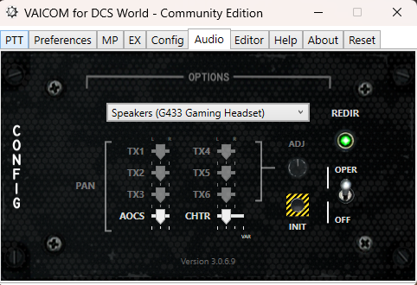

- ON/OFF SWITCH: The main switch on the right side of the panel determines whether to use the audio redirect feature (OPER) or not (OFF). When set to OFF, the system is bypassed and everything functions as normal. When set to OPER, the comms audio is redirected to the device selected in the dropdown list. The indicator light will switch to green when the selected audio device initialized correctly. If there is a problem with initialization, the indicator light will start blinking and playback on this device will not be possible: select another device from the dropdown.
- PAN SLIDERS Left/Mid/Right/Random panning for AOCS and Chatter audio can be set with the sliders.
- INIT: When redirect is enabled, this button can be used at any time to reset the audio device.

Note: The drop down list is not Plug-and-Play: restart VA if you have added or removed audio devices.

KEYWORDS EDITOR
The VAICOM PRO keywords database can be fine-tuned and edited on this page. Advanced users can use this to tailor the keywords to their individual preferences. The counter at the top left of the page shows the current total number of keywords (‘command phrases’ or ‘aliases’) in the database. The keywords editor tab contains tools to manipulate the keywords database. This is for advanced users, so if you’re new to this: try to work with the default keywords set first before you move on to tweaking things to your preference. Get acquainted with the various options and make sure you understand the steps to change and update the VA profile.
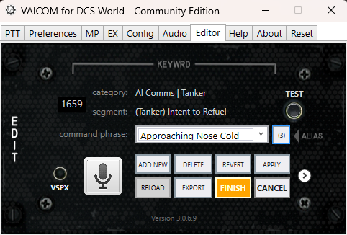

At the heart of the editor is the command phrase drop-down list. Here you can select any of the available voice command phrases. Command phrases are the building blocks of voice commands.

  - Drop-down list VAICOM PRO voice commands are built upon keyword phrases that are recognized in your spoken command sentences during gameplay. The complete set of voice command phrases is listed alphabetically. Each command phrase refers to a specific command segment. In the two lines above the drop-down list, the command segment and its category are shown for reference.
  - Alias Cycle Button Any command segment can be referred to by one or more different voice command phrases i.e. aliases, meaning you can use different voice commands to trigger the same result. For example, for the ‘Engage’ command segment you can use ‘Engage’, ‘Strike’ or ‘Attack’ aliases. Next to the drop-down list is a button with a figure. This figure refers to the number of aliases for the current command segment: if there is more than one alias then you can use this button to cycle through the available aliases.
  - Database Counter The counter on the top left of the window show the total number of keywords in the current database. The figure will update as keywords get added or deleted. If the Reload button is lit, press it to update the dropdown list and this counter.

  - Edit voice command: select the keyword you want to edit from the drop-down list. Above the drop-down box it is shown to which command the keyword is mapped.
    - Keywords Training Mode: press the microphone icon to open Microsoft Windows Voice Recognition. Here you can train the computer to better recognize your voice.
Also, you can add specific words to the Speech Library. See the section on Keywords Training Mode below for a more detailed description.
    - EXPORT/IMPORT: exports the categorized keyword list as a .csv (Comma Separated Value) file readable by Microsoft Excel, Google Spreadsheets and similar generic tools. It also creates a new HTML file which provides a hyperlinked, Formatted Keywords document. Press the white arrow button to import keywords to your database from a previously exported .csv file (the Export button changes to Import). An import database file may also contain translated dictionaries in other languages supported by MS speech recognition (e.g. Spanish).
    - CANCEL: the changes are not stored.
    - FINISH press this when done editing, see below:
IMPORTANT: CHANGES IN THE KEYWORDS DATABASE NEED TO BE REFLECTED IN THE VOICEATTACK PROFILE, THIS REQUIRES A MANUAL STEP (FINISH):
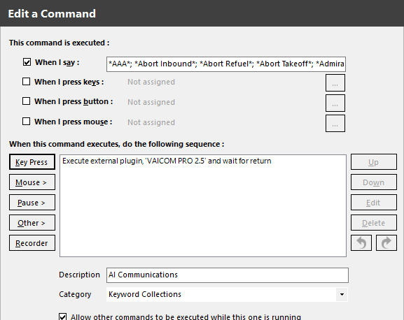
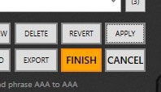
When you have made changes in the keywords editor follow the correct steps to make sure you can use your up-to-date keywords. The keyword list of the plugin current database needs to be reflected in the Voice Attack profile. A manual action is required: (This includes resetting your database keywords and imported keywords)
- Click FINISH
- Edit VA profile (pencil icon)
- Edit Keyword Collections command
- Clear ‘When I Say’ contents (Ctrl-A, Delete)
- Paste the new content (Ctrl-V)
- Store with OK.
update VA profile:

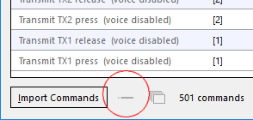

Note: Multipart commands must be consolidated i.e. collapsed, see -- icon in above screenshot.
- When done editing press the FINISH button: the new keyword list is now in Windows clipboard,
- In the profile edit the Keyword Collections command and paste (Ctrl-V) the keyword list in the ‘when I say’ field after first clearing the field with Ctrl-A, Delete. Store with OK.

HELP PAGE
The Help page provides buttons that provide access to support tools and diagnostics. It also provides quick links to the Vaicom manual, HTML keywords reference list as well as video tutorials on YouTube.
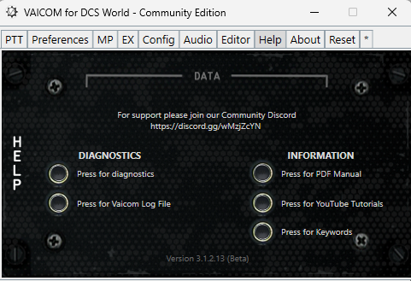

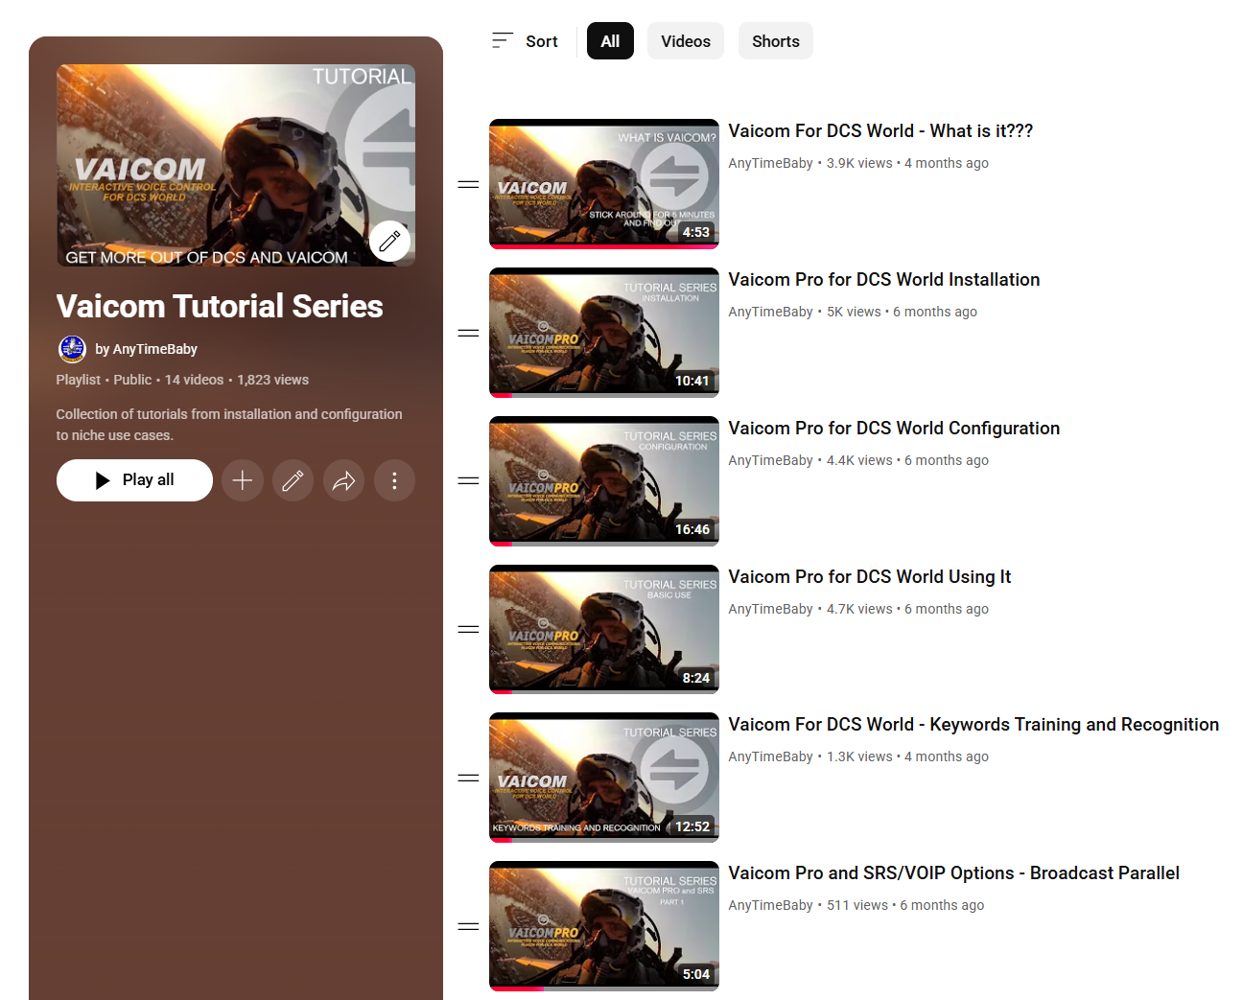

RESET PAGE
This page allows the plugin to be reset to its factory defaults. It contains a Master Reset button with which you can reset one or several of the following items: Keywords database, Preferences and configuration settings, Voice Attack profile (.vap file), DCS theme, Lua code (refer to page 42). After a reset you’ll need to restart Voice Attack.
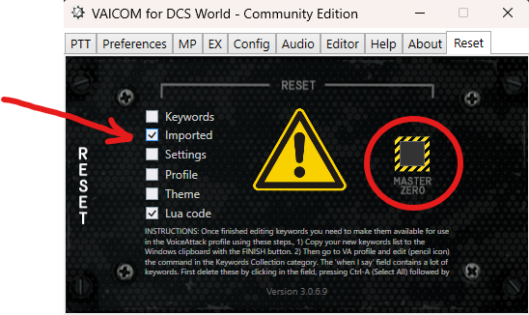

Plugin uninstall:

To completely uninstall VAICOM PRO, select all above options and reset. Next, do not restart Voice Attack. Instead remove the VAICOMPRO subfolder and its contents from Voice Attack/Apps folder.

OPTIONAL: THE VAICOM PRO APP (VAICOMPRO.exe)
Note: Use of the VAICOM PRO application is currently optional. No plugin function described in the manual depends on this app in any way, and you can do without it if you don’t want to use it.

In the VAICOMPRO folder where VAICOMPRO.dll is located, you’ll find a VAICOMPRO.exe executable file. This is the VAICOM PRO application. The VAICOMPRO app is an extremely lightweight tray app, using 0% CPU and resources. It can be run to provide the following functions:

- When starting the VAICOM PRO app, it begins with automatically launching Voice Attack for you, so it is a convenient one click starting point.
- If you create a shortcut for the app and add the -force profile argument, it also automatically selects the VAICOM PRO for DCS World profile for you in VA (see below).
- The app runs in the system tray. Anytime Voice Attack exits or crashes (i.e. enters non-responsive state), the VAICOM PRO app automatically restarts VA so you can continue flying your mission hands- free.
- It also has a manual VA reset option (right click)
- Bonus feature: double clicking the tray icon opens the plugin configuration window.

The VAICOM PRO icon is visible in the system tray while running and can be exited at any time with right click menu. Note that closing VA does not close the VAICOM PRO app (it will restart VA).

Note: Before you start considering using the app, the plugin .dll must be installed according to the instructions in this manual and confirmed working correctly. The VAICOMPRO.exe file is located in the Voice Attack Apps/VAICOMPRO folder, same location as VAICOMPRO.dll. Leave it there.

Create a shortcut if you want to e.g. start it from your desktop. By creating a shortcut, you will also have the option to add a command line option (see screenshot).
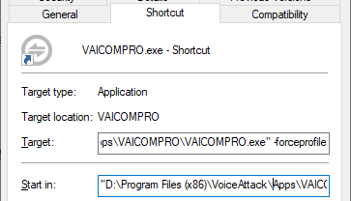

Command line option -forceprofile automatically loads the VAICOM PRO for DCS World profile into Voice Attack (it must be in VA’s profile dropdown list) on launch, even if another one was active earlier. Also, if you incidentally switch to another profile during the session, the app will immediately re-load the VAICOM PRO for DCS World profile in VA automatically. This safeguard ensures continuity and auto-corrects any unintended in-flight profile switching.

KEYWORDS TRAINING MODE

Clicking on the square microphone icon on the Keyword Editor page takes you in and out of Keywords Training Mode. When this special mode is active you can train the individual keywords / phrases with the Microsoft Windows Speech Recognition engine.

A separate MS voice recognition window opens for this purpose. This recognizer is loaded with the complete set of VAICOM PRO keywords (some 470 by default) but with no other keyword sets. This means it will only recognize the VAICOM PRO phrases as defined in the database and any other words you say will be rejected. This creates a dedicated, focused training environment. In Training Mode, you control start/stop listening by clicking on the round mic icon in the Recognizer window.

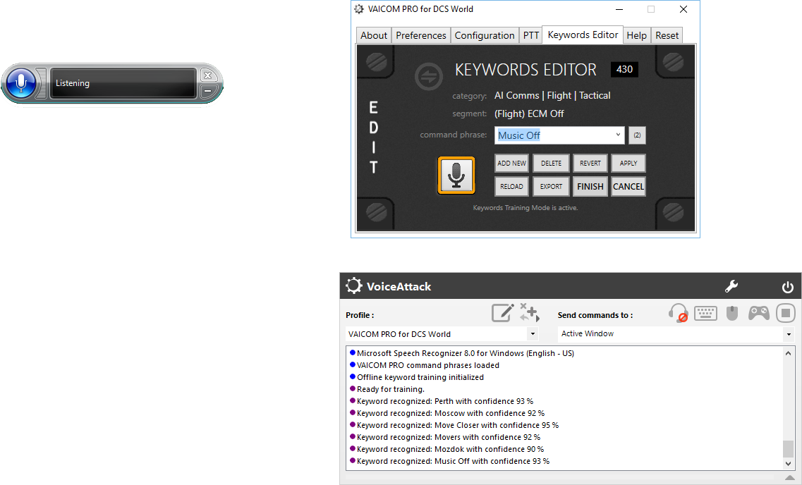
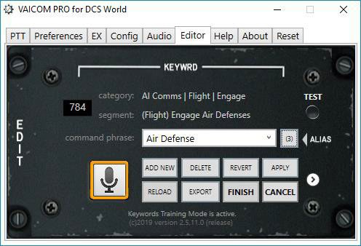

For Keywords Training Mode observe the following:

  - Use Training Mode without DCS World running.
  - In Training Mode you do not use PTT: all TX nodes are disabled.
  - Instead you enable Listening in the Microsoft Speech Recognition window by clicking the round microphone icon, leaving it in Listening mode until done.
  - Keep the Keyword Editor page from the plugin Configuration Window open.
  - Once MSVR is listening, click on the keywords dropdown list in the Editor page and use the Arrow Up and Arrow Down keys on your keyboard to step through the individual command phrases.
  - Read each command phrase out loud and check in the VA log if it is properly recognized.
  - In the Voice Attack window you will see when a phrase was recognized and with which confidence level (%). Higher is -you guessed it- better.
  - If a word is not recognized immediately, keep trying. Try changing emphasis. If after several tries you cannot make the recognizer understand a particular phrase, make a note and continue training with the next words. Read below on next steps for these stubborn words.
  - It is recommended to grab some coffee and in a 30 mins. session go through each of the 470 keywords. It will help you memorize all the available phrases (some of which you perhaps not even knew existed). This will train the engine, and you can isolate which words are troublesome for recognition for your personal case (as this can vary quite a bit).
  - Once you are done with training you will need to manually close the MSVR window yourself, the plugin will not do this for you.
  - Click on the square microphone icon again to exit Training Mode.

Managing problematic words

In the large collection of keywords there are likely a few words that give trouble i.e. the recognizer does not catch them effectively with your voice. For troublesome words you can do these things:

    - Use the Keyword editor to change the phrase into something that is better recognized by the engine, or:
    - Add the keyword to the Microsoft Speech Library.
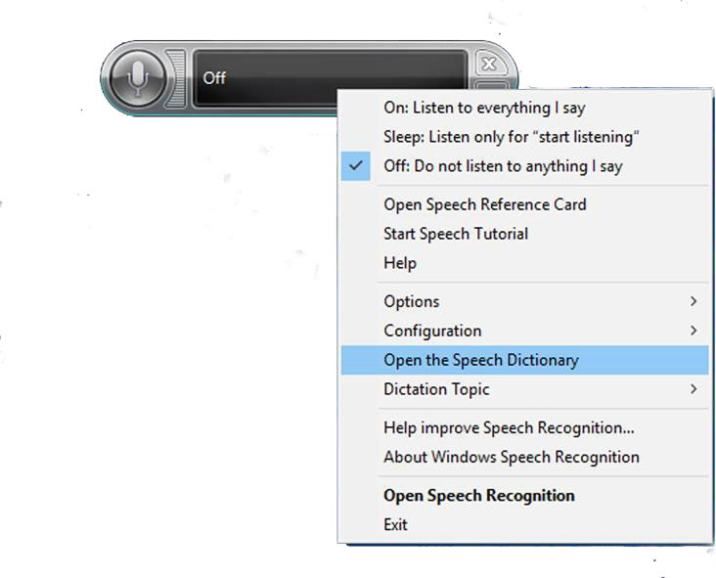
When you right-click the Recognizer window you have the option to select ‘ Open the Speech Dictionary’. You can add new words here to improve their recognition. You can add new words here by using copy/paste from the drop-down list in the Keywords Editor window and then record a new pronunciation with your voice. For some situation this can work miracles to improve the overall recognition of specific stubborn keywords / phrases.

Note: It is recommended to do this only for words that you cannot get properly recognized. Adding all VAICOM PRO keywords for example is definitely not recommended, it should normally only be a small number for which this step is required.

ADVANCED CONFIG & DCS UPDATING

Important Information about DCS World updates

Every time DCS is updated to a newer version or repaired It will overwrite the files VAICOM PRO needs to function correctly. This is not normally a problem, as each time VAICOM PRO is run it will re-build its files in DCS.

Problems arise if VAICOM PRO is not shutdown prior to updating or repairing DCS. Similarly after a DCS update, If DCS is started before VAICOM PRO, the software can not apply the required patching to DCS and issues will be encountered in the way VAICOM PRO interacts with DCS.

Order Of Operation

It is important that you follow this order of operation when Running Vaicom Pro.
- Start Voice Attack and VIACOM PRO as Admin (It will patch/ build the required scripts) or update itself if an update is available.

- Start DCS World

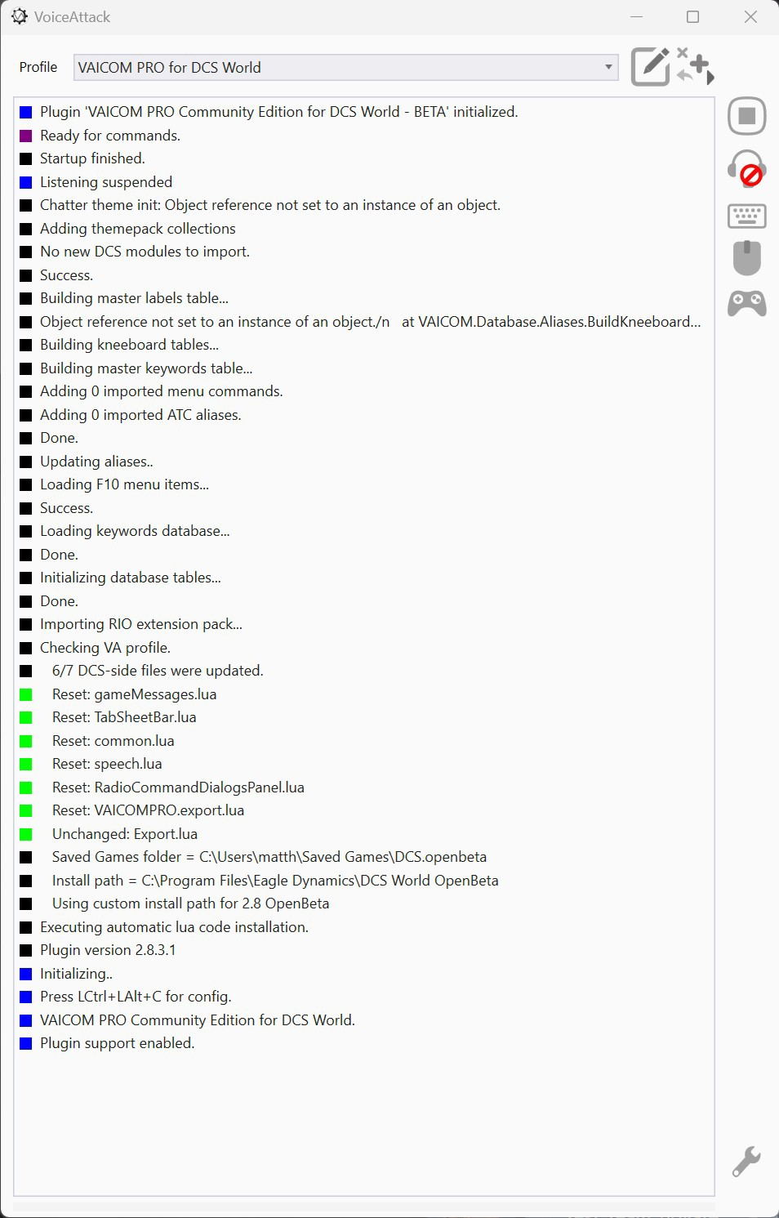
Note: If you turn on Debug in preferences you will see VAICOM PRO build its files .

Managing DCS-side (lua) files manually

Each time the VAICOM PRO plugin initializes it check for local DCS World installations and whether the required .lua script files to run VAICOM PRO are already installed. If not, it will install them automatically. You can select the ‘Managing DCS-side files manually’ option to disable this feature. You can then manage the lua files yourself.
Note: Manual .lua install is prone to user error and definitely not recommended in general. Manual .lua files handling should not be necessary except in very particular circumstances.
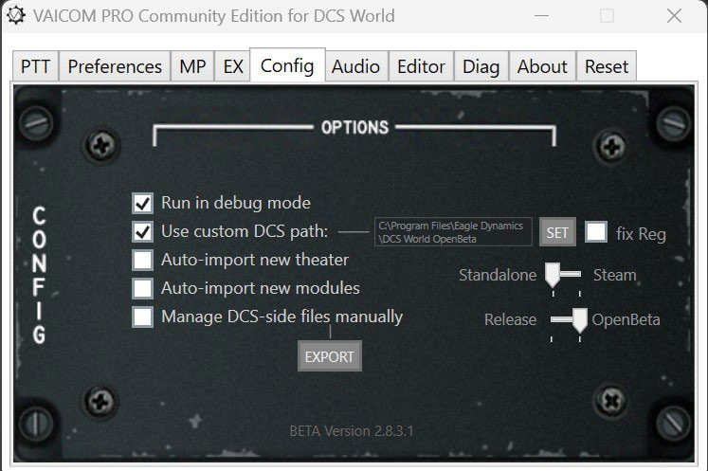

Note: For below steps note that each DCS version has its own set of folders so you may need to repeat these steps for other DCS versions if you have more than one version installed.

Press the Export button to find these new .lua files in the Export subfolder:

- Export.lua This is an append file. Open this file in Notepad++ and select all contents for copy with Ctrl-A, Ctrl-C. Next find the existing export.lua file in the Saved Games/DCS/Scripts folder (create a new empty export.lua file if it doesn’t exist yet). Then Paste (Ctrl-V) the contents into the export.lua below whatever else may already be in there.
- VAICOMPRO.export.lua Create a subfolder named ‘VAICOMPRO’ (use capitals) in Saved Games/DCS/Scripts. Place the exported file VAICOMPRO.export.lua in there.
- RadioCommandDialogsPanel.lua This is an append file. Open the file in Notepad++ and select all contents for copy with Ctrl-A, Ctrl-C. Next find this folder: ‘DCSWorld\Scripts\UI\RadioCommandDialogPanel’ and open the existing RadioCommandDialogsPanel.lua file there with Notepad++. At very lower end of this file paste the copied contents with Ctrl-V and save.
- TabSheetBar.lua Append file, found in the same folder as 3). Follow the same append steps.
- gameMessages.lua is placed in the Scripts/UI folder.
- speech.lua Also an append file. Add the contents of this file at the end of the speech.lua file located in folder ‘DCS World\Scripts\Speech’.
- Do the same with common.lua, in the same folder as speech.lua.
Once the above is all done you can clear VAICOM PRO’s Export subfolder.

INTERACTIVE KNEEBOARD EXTENSION

The ultimate in DCS integration is VAICOM PRO’s dynamic kneeboard extension. This optional add-on allows you to have direct in-sim access to written-down references of important communications such as for JTAC 9-lines and remarks, AWACS an AOCS status reports, and to add your own dictated notes using just the standard DCS kneeboard. Working with the kneeboard as your dynamic scratchpad during the mission brings immersion to unprecedented levels. What’s more, it also provides reference to your own personalized alias keywords database, so you will have an immediate view on the voice commands available to you when needed. Perfect for initial training and when learning to work with advanced voice comms.

Overview

VAICOM PRO’s kneeboard page is automatically bookmarked, as shown by the yellow post-it. At the top, it shows tabs for the various notepad categories. At the start of the new mission, it defaults to the first tab which shows printed Air Tasking Order (ATO) and briefing summary information.

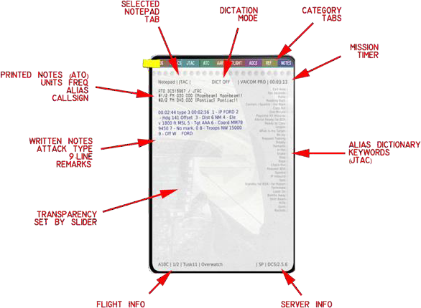

Other tabs include those for categories such as ATC, AWCS and JTAC, and lastly there is a NOTES tab for your own notes added by voice using Dictation Mode.

Opacity

The notepad’s overall opacity can be set with the vertical slider on the EX tab of the plugin configuration window. This slider affects transparency on desktop monitors only: in VR mode the kneeboard is always opaque.

Mission timer

At the top right you can check the mission timer to see how long your mission has been running. Some written notes will have timestamp references. As a side note: if you are on long missions, you will see that your notepad page gradually becomes more smudgy!

Dictionary keywords

At the right-hand side of each category page there’s a listing of command aliases for that category. So
e.g. on the JTAC tab, JTAC command keywords are shown. This listing is based on your personalized VAICOM database: if you have edited the default database using the keywords editor it will be reflected here. Note that only one alias is shown for each command. This means that if you have several aliases for a command you will not see all of them listed. You’ll still need to memorize keywords: the idea is not to have a complete dictionary on here, but a fast and convenient backup in case you forgot something. This is especially useful if you’re a new VAICOM PRO user learning the various commands.

Browsing through tabs

You can open/close the kneeboard by saying ‘Kneeboard’. Browse to a specific tab with the “Page” keyword, i.e. “AWACS,…Page”. Say “Show Notes” to select the dictation page and “Show Tasking Order” to bring up the ATO briefing summary tab.

When the Auto Browse option is selected (EX tab), tabs are automatically and dynamically selected: if you say ‘JTAC,..’ and the ‘awaiting additional input’ blip is heard, the kneeboard will instantly switch to the JTAC tab. You can then read relevant info from the notepad page before completing your voice command. Note: this does not apply to VSPX recognition mode.

ATO categories info

Printed at the top of each category page is a unit list excerpt from the Air Tasking Order. It tells you which units are available in the mission and the frequency on which to contact them. In the square brackets, the corresponding callsign alias is shown i.e. the recipient keyword you should use with your voice commands to hail them. If you have edited the recipient alias in the keyword editor, it will be reflected here.

Written notes

The written notes (blue ink) are added automatically as new information becomes available through your various communications with AI units. There are various messages e.g. AWACS alpha check, ATC vectors, AOCS updates etc. of which summaries will be written on your notepad during the mission. For example, when you contact a JTAC operator and establish 9-line information exchange, VAICOM PRO will automatically scribble the 9-line data on the JTAC page for you using a condensed shorthand style. Like in reality, it will take a second or two to write things down.

How to use

Writing of notes is automated and does not require specific additional user action.

- As always, use PTT for every command.
- Use the “Kneeboard” voice command to toggle kneeboard visible
- Call e.g. “AWACS…Page” or “JATC…Page” etc. to browse to a tab
(enable the Auto Browse option (EX) to browse without use of the Page command)
- To test, check in with a JTAC operator and request nine-line briefing (“Ready to Copy”)
- During the JTAC response, the nine-line info appears as written notes on the JTAC page,
- Request AWACS vector to home base and a note gets added,
- Etcetera.
Note: Not every single reply you get from a recipient will necessarily be written down on the notepad. Only relevant info is penned.

Note: When the page is full, additional lines will be added at the expense of the topmost lines. You cannot browse back i.e. only most recent notes are visible on the page.

Dictation Mode

Dictation Mode is used to add your own notes to the kneeboard using speech. The dictation notes are written on the NOTES tab. This tab is automatically selected when you enter dictation mode or when you call ‘Show Notes’. At the top of the page, a red [DICT ON] bug informs you if Dictation Mode is active.

How to use dictation mode:

A PTT key must be used for speech, also in Dictation Mode. Start by pressing PTT (any TX node) and calling ‘start dictate’ to switch on Dictation Mode. Now, press PTT again and say any random phrase that comes to mind. Dictation Mode (that is, Windows Speech Recognition) will try its best to make sense of what you said, and a written line will be added to the NOTES tab. The line can take about a second to appear on the kneeboard: this is normal.

MS Windows will do its best to come to sensible sentence based on your speech, but mileage may vary. Bear in mind that the recognition function is NOT handled by the plugin (or Voice Attack for that matter) but by Windows itself.

Hold PTT or release PTT and press PTT again to start entering your next line to the notepad. If the captured line is okay, just continue with the next line. If the line was not okay, you can use the ‘correction’ keyword to erase the last line and then try again.

When you’re finished dictating, say ‘end dictate’ to exit Dictation Mode. The bug will show DICT OFF. The notes are kept on the NOTES page and you can use ‘show notes’ to browse back to them at any time.

Advanced option: keyboard/joystick control

For normal use you do not need keyboard or joystick to control the Interactive Kneeboard functions. However, if you do wish to have the ability to browse the category tabs with keyboard keys / joystick buttons, you can add additional commands to your Voice Attack profile to do so. Also, the kneeboard opacity slider can be controlled in this way if desired.
Proceed as follows:

- Create a new command in Voice Attack profile,
- Use option Other / Advanced / Execute an External Plugin Function,
- In the plugin context field, putting any of the available API control commands listed below
- Configure any key/button to trigger this command,
- Etcetera.
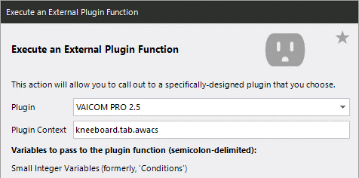
API control commands:

- kneeboard.tab.log
- kneeboard.tab.aocs
- kneeboard.tab.jtac
- kneeboard.tab.tanker
- kneeboard.tab.awacs
- kneeboard.tab.atc
- kneeboard.tab.flight
- kneeboard.tab.ref
- kneeboard.tab.notes
- kneeboard.tab.prv
- kneeboard.tab.nxt
- kneeboard.opac.up
- kneeboard.opac.dn

Keywords reference

Refer to page 80 for a listing of all Interactive Kneeboard -related keywords.

OPENKNEEBOARD OUT V2

OpenKneeboard OUT is the latest advancement in taking the enormous amount of data Vaicom monitors and allowing in game access for the pilot. Leveraging the awesome OpenKneeboard application, it is activated from the Extensions tab by checking the OKB Out checkbox. This does two things, it starts the OpenKneeboard OUT web dashboard running and creates a plugin for OpenKneeboard. The Port setting can be used to assign your own port if you have a port conflict with another device or service, cycling OKB Out checkbox will start broadcasting on the new port. You will need to shutdown OpenKbeeboard and restart it to accept the new port via the Vaicom OKB out plugin.
Adding Valcom’s plugin to Openkneeboard is very simple, start Opnkneeboard, navigate to settings > Tabs. Then select the Tab+ button.
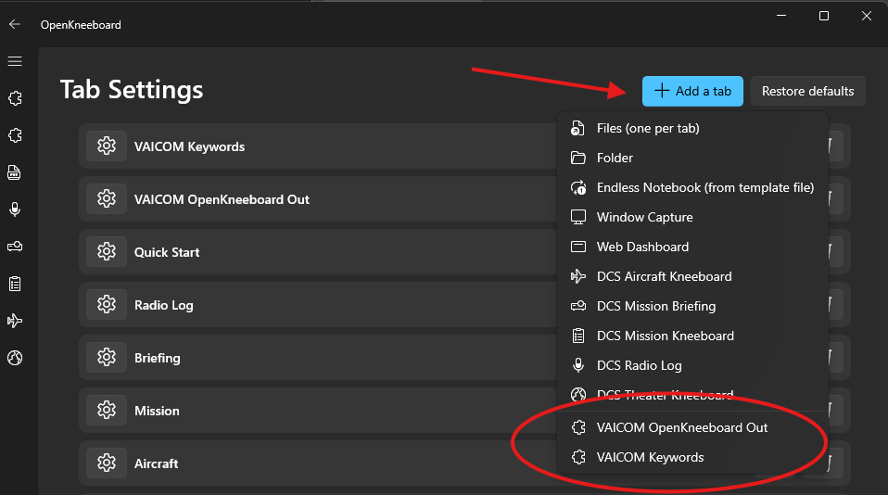
Select Vaicom OpenKneeboard Out plugin and you will now have the new interactive Vaicom Web dashboard installed as a tab in OpenKneeboard. (If you have viewed the Vaicom Keywords reference via the Help Tab you will have a second plugin present for the Vaicom Keywords)

Overview
Navigating the Vaicom web dashboard can be managed in two ways, via voice commands, the same as the legacy DCS kneeboard overlay. Or it can be stylus clicked in VR using the tab structure on the right.
OpenKneeboard Out is designed for the use of a draw tablet and stylus, there is a way to use the mouse to interact with it in VR, however it is not ideal due to focus changing to OpenKneeboard. (Data will only populate, and is refreshed by using a voice command, this reduces draw calls and holds information allowing the pilot to control when to update or refresh the kneeboard)
The kneeboard has five main global controls:
- Status Dialog. This provides a continuous feed from Voice Attacks log, with warnings, errors and command success messages. It also has the connection status for the web dashboard.
- Session Information. This is a collapsable window that gives current module and mission information drawn directly from a connected DCS session.
- TABS. The main working window provides output information for the selected TAB, Mission Briefing, Units, frequencies, Bearing Range and Altitude (BRA), etc. This is customised depending on what tab is selected. If the displayed information exceeds the window size a scroll bar will appear allowing access to the full information provided.
- Settings. Global settings for Vaicom OpenKneeboard Out.
- Help. Open tab focused help documentation on the Kneeboard in VR.

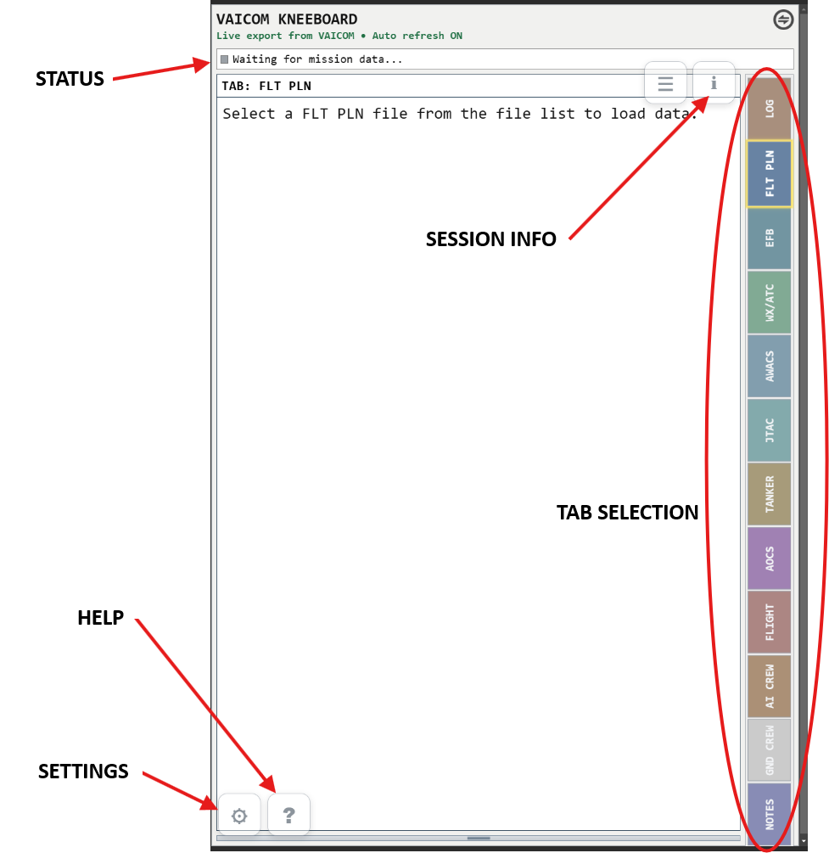

How To Use It?

The OpenKeeboard Out HTML manual is available by pressing the button on the Vaicom UI OKB Out tab. This documentation is also available on the Kneeboard via the help icon and provides tab focused controls and usage information. You will need to read this to understand the functions of OKB Out and it includes detailed descriptions of the different functions of the EFB and FLT PLN tabs the most complex tabs on the kneeboard.
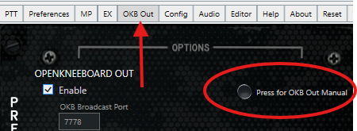

Limitations

By design OpenKneeboard OUT will not provide unit information for player or client aircraft of another coalition, it will provide datalink traffic if a friendly AWACS is providing it but only to AI units. This is in place to prevent the dashboard being used in multiplayer PvP as an all-seeing situational awareness tool.

AI CREW DIALOG EXTENSION

The AI CREW Dialog extension for VAICOM is a highly advanced voice-based AI interface which lets you have immediate dialogs with your F-14 Jester back seater, Iceman AI Pilots (when you’re in the backseat of the Tomcat) as well as your AH-64D Co Pilot Gunner (GPG) without seeing any on-screen menu wheels or using the keyboard. AI CREW makes the interaction with Jester and George 100% natural and adds greatly to speed and immersion in the heat of complex missions where close flight crew cooperation is critical.

Before setting up

- You must have a fully working plugin installation before activating Jester AI. VAICOM PRO plugin version must be 3.0.1 or higher, Voice Attack version 1.16.1 or higher.
- You must have the plugin automatic lua files install mechanism working (using default automatic or via the Custom Path option) in order to use the AIRIO extension. AIRIO does not work with manual .lua installation (which is not recommended in any case, unless in very exceptional circumstances).
- The AI Crew system replaces the Menu Wheel in the case of the F-14: the Menu Wheel is not available when Jester AI is enabled and vice versa. However, a back-up is available using the Options command, i.e. ‘Jester,.. Options’ (or ‘Ice,.. Options’) brings up the Jester menu. Keep holding PTT and use ‘Take 1’, .. ‘ Take 2’ etc. voice commands to step through the options, just like with the regular Options function (see page 19). Releasing the PTT button closes the Jester menu.
- AI Crew commands are only available when flying the module they are intended foruse with I.E. Jester F-14 and George AH-64D jester commands cannot be used with George and the reverse is true.

Setting up
- Confirm on the EX tab that the Jester AI Enable option is selected for F-14.
- Enable Extended Command Set on Preferences page. Restart both VA and DCS.
- After VA restart, new keywords will have been added to your alias database. Follow the regular FINISH steps (see page 30) to update your VA profile with the new keywords.
- Restart VA again, and then start DCS.
- In DCS options under Special, confirm the Radio Menu setting for the F-14 is Default.
- Look on next page for adding additional Jester AI commands to your VA profile. George AI commands are already added to the database and managed by Vaicom normal profile update processes.

Adding additional VA profile commands for Jester 2.0 AI F-4E WSO

Follow below steps to add these Jester AI commands to your VAICOM for DCS World profile.

Note: Unless these commands are added to your VA profile you will e.g. not be able to use the AIWSO options for navigating steerpoints, Radio and TACAN tuning and some other diversion and fuel commands.
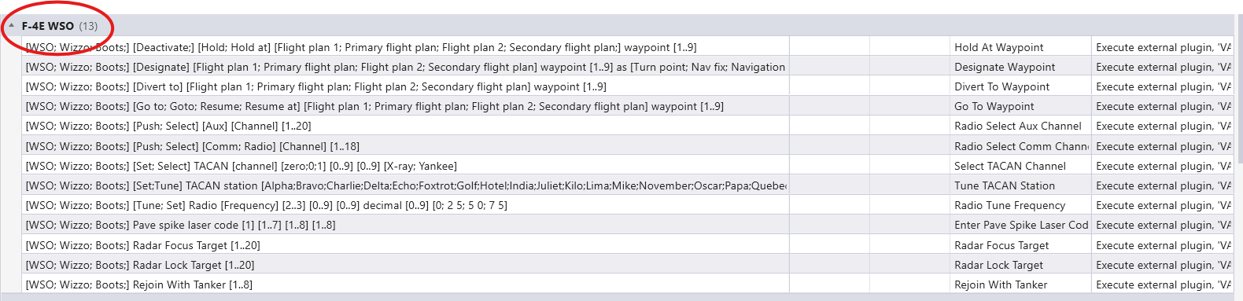

To start, open your profile in Voice Attack and look for in total 9 AIRIO and 13 F-4E WSO commands in category Expansion packs and F-4E WSO. If these commands are already present, then no action is needed. If not, follow below steps to add them:

- Open the plugin Configuration page and on the Config tab click on the EXPORT button.
- The profile folder contains a file called ‘VAICOM F-4E WSO.vap’
- In Voice Attack, select Import Profile and import this VAICOM F-4E WSO.vap file
- Next edit the VAICOM PRO AIRIO profile (click pencil icon)
- Select each command (there are 13) and select Import.

Continue to use your VAICOM PRO for DCS World profile as usual.
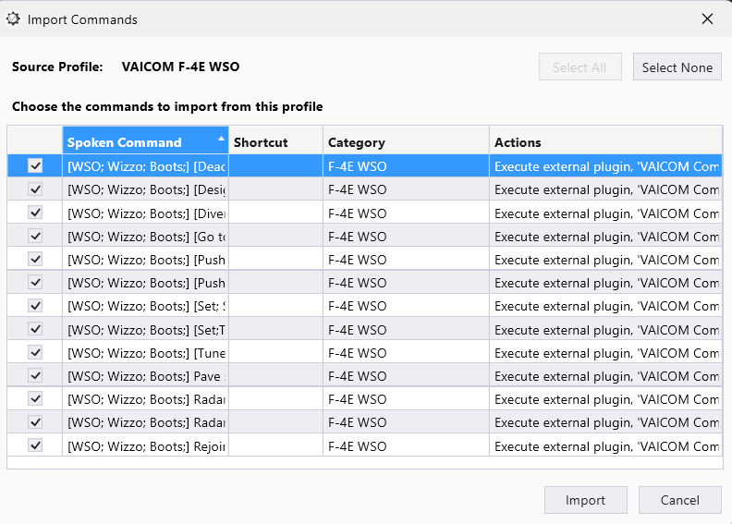

Note: As an alternative to above steps, advanced users can daisy-chain the AIRIO profile to their VAICOM PRO for DCS World master profile if desired.

Usage / During flight

  - You can use any TX node for AIRIO commands, using the TX5/ICS node would be the formally correct way to do it. ICS Hot Mic functionality is also available as an option.
  - AIRIO database aliases can be manipulated (edited, new aliases added, translated etc.) just like the regular dictionary keywords.
  - RIO and Iceman are optional recipients: you can use their names (“Jester,..”) in your phrases but you don’t have to, all RIO commands are automatically directed to your crew member.
  - Do not consider the Menu Wheel names/labels/listings to be your commands reference. When using AIRIO, refer only to the commands reference tables stated in this user manual (pages 63-70).
  - Audio Redirect is not available for Jester speech: it is recommended to switch off Redirect or select (default) device.

Jester manual tuning commands
Complementary to the recipient-based tuning offered by the VAICOM PRO plugin (using the Select command for radio tuning to a specific recipient, TACAN Tune Texaco to tune TACAN immediately to a nearby tanker, etcetera), AIRIO now also has the option to have Jester execute manual device tuning. The RIO can be made to perform frequency tuning for the AN/ARC-182 radio, Datalink and TACAN devices. Voice command usage is as follows:

Link Tune [0..9] [0..9] decimal [0..9]
Sets the Datalink frequency. Examples:
“Link Tune two two decimal seven” – DL frequency is set to 322.70 MHz
“Link Tune zero five decimal four” – DL frequency is set to 305.40 MHz

Radio Frequency [0..3] [0..9] [0..9] decimal [0..9] [0; 2 5; 5 0; 7 5;]
Sets the AN/ARC-182 radio frequency. Examples:
“Radio Frequency two three five decimal nine zero ” – Radio frequency is set to 235.900 MHz “Radio Frequency zero eight five decimal zero two five” – Radio frequency is set to 085.025 MHz

TACAN Tune [X-Ray;Yankee] [0..1] [0..9] [0..9]
Sets the TACAN frequency. Examples:
“TACAN Tune X-Ray one two nine ” – TACAN channel is set to 129X,
“TACAN Tune Yankee zero eight six” – TACAN channel is set to 086Y.

Scan Range, [0..150] [On the; Angels] [Deck; 0..70]
Radar scan specific sector (use multiples of 5 for the numbers). Example:
“Scan Range, fifty Angels forty five” – Scan focused at 50NM at 45.000ft.

Map Marker [1..10] to [Waypoint 1..3 ; Steerpoint 1..3 ; Fixed Point; Initial Point; Surface Target; Home Base; Defense Point; Hostile Zone; Grid]
Sets the map marker as reference point. Examples:
“Map marker one to waypoint two ” – F10 Map marker 1 is assigned to WP2, “Map marker seven to surface target ” – F10 Map marker 7 is assigned as target.

In-flight assistance: show options
  - There are various AIRIO root commands that you can use during flight to provide you with guidance if needed. These will provide on-screen information when the ‘Hints’ setting is selected on the EX tab. In the reference tables these root commands are listed with ‘(show options)’.
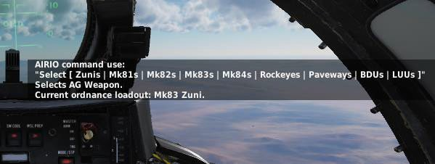

In above screenshot the hint is shown for the ‘Select Stores’ command as an example. The displayed message provides info for general command usage, and also shows the options currently available: AG stores types Mk83 and Zuni are loaded on the aircraft so commands ‘Select Zunis’ and ‘Select Mark 83s’ can be used here.
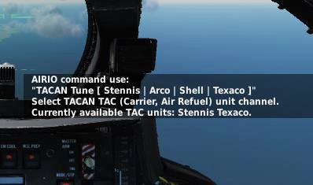

Above example hint screenshot is for ‘TACAN Tune’ command: the TACAN TAC units Stennis and Texaco are active in the current mission area and can be used in commands: i.e. ‘TACAN Tune Stennis’ or ‘TACAN Tune Texaco’. Similar info is in place for ’Link Host’ DL command.

  - VAICOM’s regular commands (‘Select’) can be used to tune radios in the F-14. The radio for which you have pressed the corresponding TX/PTT key is tuned (i.e. ARC-159, ARC-182).
  - For Easy Comms Off, make sure the Select Tunes Radio option is selected in Preferences.
  - Optionally you can use the ICS HOT MIC switch in the aircraft to talk to your RIO without using PTT. Voice Attack will then be in listening state throughout the mission. Note: be aware that using open mic can lead to less reliable overall speech recognition.

DIALOGS TRAINING REFERENCE

Below flow tables provide a training reference for practicing procedural dialogs with voice recognition using VAICOM PRO.

For ATC and JTAC specifically it can be helpful to get a basic idea of the regular steps involved and their order. You are not specifically tied to these steps as there is no sync to be maintained between DCS and VAICOM PRO. The communications interface is directly with the FSM core of DCS World which means you can issue any voice command at any time. Whether you will get an appropriate response or not will depend on the stage of the flow. But, you cannot ‘get stuck’ in dialogs as was an issue with previous VAICOM versions which relied on using the menu interface.

ATC dialogs

Below tables capture regular procedure steps taken for the various ATC stages (‘happy flows’). In addition to these there are additional commands that can be used with ATC. See Keywords Reference section for full ATC commands listing.

Stage Ground – before takeoff
status | use voice command | notes
Parked at the ramp | Request Engines Start | Then execute startup procedure
Ready for Taxi | Request Taxi to Runway | Proceed to Runway, hold short
Ready for Takeoff | Ready for Departure | Line up and take off

Stage Air
status | use voice command | notes
Navigating | Request Vector
Inbound | Inbound
Approaching | Overhead Approach
Request Landing | Request Landing

Stage Ground – after landing
status | use voice command | notes
Landed, on runway | Request Taxi to Parking | Exit to parking area

JTAC dialogs

Below tables show typical example dialog for the various JTAC stages (‘happy flows’), to be used as a guideline for training voice commands with JTAC engagements (especially when you have menus set to invisible). In addition to these there are additional commands for JTAC, such as Repeat Brief, What is My Target, Unable etc. which can also be used most of the time during the engagement. You can state the command phrases literally as written here, but you are free to vary the exact way you state your commands since VAICOM interpretation is keyword-based.
Note: Look carefully into these flows as they also contain additional commands such as ‘Copy Miss’ which are not part of DCS’ standard package. There are several more interesting keywords that you can use, listed in the Keywords Reference section (‘Guns! Guns! Guns!’).

JTAC type 1/2 engagement

Stage Establish (check in)
ref | player call | JTAC call | remarks
 | ‘JTAC, Enfield 11, playtime 30 minutes’ |  | Enfield checks in
‘Enfield 11, this is Firefly.
Welcome, advise when ready for 9-line’
Stage Briefing
ref | player call | JTAC call | remarks
B | ‘Enfield 11 ready to copy’
 |  | (reads 9-line), advise when ready for remarks
 | ‘Any remarks?’
 |  | (reads remarks)
 | ‘Copy nine line’ |  | or 'Reading Back',..
 |  | Readback correct. Advise when IP Inbound.
Stage IP Inbound
ref | player call | JTAC call | remarks
IP | ‘Enfield 11, IP Inbound’
 |  | Continue.
Stage Setup (for WP type)
ref | player call | JTAC call | remarks
 |  | Mark is on the deck.
 | ‘Tally Smoke.’ |  | or ‘Contact the Mark’
 |  | (reads target distance from marker) | Proceed to Stage Engage
Stage Setup (for IR type)
ref | player call | JTAC call | remarks
 | ‘Sparkle’ |  | Commands IR wand on
 |  | Sparkle.
 | ‘Snake’
 |  | Snake…
 | ‘Steady’
 |  | Steady….
 | ‘Contact Sparkle.’ |  | Proceed to Stage Engage
Stage Setup (for LASE type)
ref | player call | JTAC call | remarks
 | ’10 seconds’
 | ‘Laser On’
 |  | Lasing.
 | ‘Shift’
 |  | Shift...
 | ‘Tally Ray.’ |  | Or ‘Spot’. Proceed to Stage Engage
Stage Engage
ref | player call | JTAC call | remarks
 | ‘Enfield 11, In from the West.’
 |  | Cleared Hot! | Enfield fires
 | ‘Enfield 11, Exit Area’ |  | Enfield egresses
 |  | Target is not destroyed. | Enfield is a poor shot
 | ‘Copy Miss.’ |  | Syncs to re-engage (ref IP). Note: you’ll hear ‘IP  Inbound’ if player voice enabled.
(re-engaging after initial miss)
ref | player call | JTAC call | remarks
 |  | Enfield 11, continue.
 |  | Mark is on the deck. | WP type attack
 | ‘Copy Smoke’
 | ‘Tally Smoke’ |  | When visual on mark
 |  | (reads target distance from marker)
 | ‘What’s my Target?’ |  | Optional but typical step
 |  | Target is AAA.
 | ‘In from the East’
 |  | Cleared Hot!
 |  | Target destroyed. | Finally.
 | ‘Confirm kill’ |  | Syncs back to Briefing stage (ref B).
 | ‘Request new task’ |  | i.e. Ready to Copy 9-line
 |  | (reads 9-line), advise when ready for remarks
Stage Establish (check out)
ref | player call | JTAC call | remarks
 | ‘Firefly, Enfield 11, checking out.’ |  | Enfield checks out
 |  | Thanks, bye.

KEYWORDS REFERENCE

The Vaicom keywords and phrases are now auto generated into a HTML document. This ensures users have an easy updated list of commands that is organised and hyperlinked. You can use the keyword editor to change the phrases to your personal preference and add additional keywords, these will be exported as aliases in any refreshed HTML export.
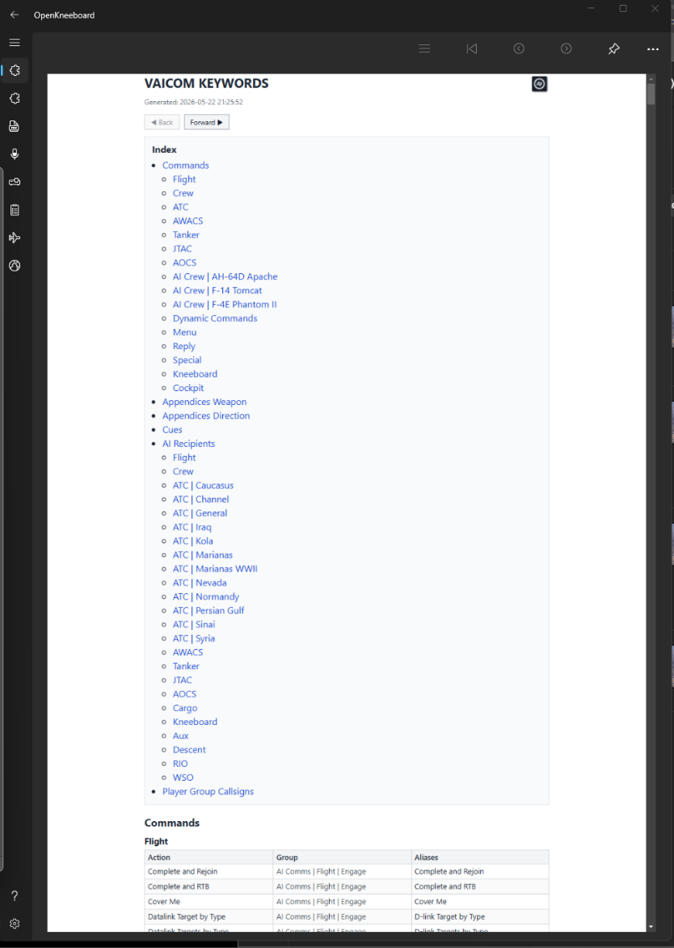
The HTML document contains print CSS formatting to ensure printing to PDF or Paper is clean. It also generates a plugin for OpenKneeboard. This allows a customised browser with navigation buttons forward and back to previously referenced sections.
Vaicom Keywords can be accessed from the Help Tab of the Vaicom UI. When accessed from here it also generated the OpenKneeboard plugin.

Generic voice command structure

VAICOM PRO voice command interpretation is keyword-based. All VAICOM PRO voice command phrases are used in the Voice Attack profile with an asterisk wildcard before and after the phrase, indicating the keyword can be used anywhere in a spoken sentence. The generic structure for VAICOM PRO voice commands is as follows

[<recipient>], [<sender>*], [<cue>] <command> [ <appendices>]
Where the elements are Recipient Sender Cue Command
Recipient class e.g. ‘AWACS’ or recipient callsign e.g. ‘Magic’.

Player callsign, e.g. ‘Springfield 11’. Use of player callsign is optional and for general command interpretation it is not required to use.
Note: *) with VSPX speech processing mode, sender cannot be used.

Note: During a mission you can use your flight callsign e.g. ‘Springfield’ as a recipient alias for Flight. So instead of “Flight, close formation” you can call “Springfield, close formation”. Unit numbers e.g. ‘14’ etc. are all ignored.

A specific keyword to set the context. For example for the Engage command you are required by default to use a cue word in your sentence such as ‘Attack’, ‘Engage’, or ‘Strike’ . You can switch this off in Preferences, in which case just mentioning a target in your sentence is enough to issue an Engage command without using a cue word.

Any valid command for the recipient class e.g. ‘Request Picture’ for AWACS. A message is not complete without reference to a command.

Appendices For engage commands, additional info can optionally be
provided. ‘Two, Engage Air Defenses’ is valid, but in addition e.g. the appendix ‘from the North with Mavericks’ can be added to make it more specific. Note: support for specific appendices (direction, weapon) varies per DCS module. To use, the option must be enabled in Preferences.

Supporting vessels may be on the same frequency as the actual carrier: always use Select e.g. ‘Washington,.. Select’. Before entering the dialog to avoid ‘go to alternate’ responses from other battle group units. For approach, do not use the generic ATC ‘Inbound’ command but ‘Inbound for Carrier’ or ‘Marking Moms’ as listed.

Note: More commands are available than for users who use menus. The correct flow must be followed to get adequate responses during the various CASE I/II/III stages. Issue commands in the correct order during approach, meeting stage parameters. Refer to ED’s DCS: Supercarrier guide for flow details. https://forums.eagle.ru/attachment.php?attachmentid=231740&d=1586110211

Note: Automated player calls will generate a short PTT squelch sound in VAICOM when player voice is disabled in Preferences. During dialog, messages contents are visible in the Voice Attack log window. Automated calls can also be suppressed altogether (EX tab option) so that you can issue these calls yourself.

Note: The FA-18C module requires manual AM/FM modulation switching. Check this if your carrier is on FM modulation instead of default AM and you get no response.

Note: The Extended Command Set option must be enabled in Preferences.

COMMUNITY F-10 SCRIPT KEYWORDS

When Import F10 Menus is selected on the Vaicom Pro UI preferences tab, commands are added to the database and then if desired can be added to the user’s profile keywords (See page 30). Certain high use community scripts that use the F10 Other menu for functionality have pre-configured keywords that exist in the standard Vaicom Pro database. When a player loads a mission or joins a server mission that has these scripts running, provided the import F10 menus option is checked, Vaicom pro will automatically match these keywords to the script commands and the player can use them without any further action.
Support for DCS Moose Ops Airboss, Ops AWACS and Functional Range have been added, I have also added support for the upcoming AI_ATC Script. Other scripts will be added over time, Inclusion will be based on community usage and the stability of the script.
A couple of limitations, multiple objects that share the script can’t be in the same mission. E.g. two CVN Airboss objects. (You can have a CVN and an LHA). Also, Keywords need to be unique from the standard DCS ones, so “Request Taxi to Runway” couldn’t be used as it already exists in the DCS AI database.
Community script keywords are also exported to the Keywords HTML document.

EXPOSED VARIABLES

Users who wish to add their own commands to the ‘VAICOM PRO for DCS World’ Voice Attack profile can easily do so. In addition, advanced users can make use of the below Exposed Variables to create additional logic in their added VA commands.

Refer to the Voice Attack Help documentation on how to create complex commands using conditions using variables and tokens. Using the plugin’s exposed variable set you can, within the single VA profile, create a comprehensive custom command set that sends different keypresses for different aircraft.

For example, for your custom ‘Gear Up’ command you may want to send ‘G’ in the A-10C and ‘LShift+G’ in the F-15C. You can create a single Gear Up command in the VA profile, containing logic to send the correct keystrokes based on the current aircraft. The plugin makes sure that the value of the active module name variable reflects the active DCS aircraft during gameplay.

Note: a TX node must be used for PTT when using added custom commands with variables e.g. TX6. This makes sure all variables are in sync. The following exposed variables are available:

Server

- {TXT:vaicompro.serverdata.currentserver.dcsversion} - string containing DCS version number,
- {TXT: vaicompro.serverdata.currentserver.theater} – theater name,
- {TXT: vaicompro.serverdata.currentserver. mission } – current mission title,
- {BOOL:vaicompro.serverdata.currentserver.vrmode} - value True or False,
- {BOOL:vaicompro.serverdata.currentserver.easycomms} - value True or False,
- {BOOL:vaicompro.serverdata.currentserver.multiplayer} - value True or False.

Aircraft

- {TXT:vaicompro.playerdata.currentmodule.name}
  - This string contains the active module name e.g. 'UH-1H' or 'F/A-18C', This is the name designator in the PTT tab, without the Huey or Hornet.
- {TXT:vaicompro.playerdata.currentmodule.cat}
  - This string contains the active module category, value is either 'Helicopters' or 'Planes'.

PLUGIN API

This is for advanced users only. The plugin exposes API functions for invoking via Voice Attack. These functions are used e.g. for the Push-To-Talk keybinds. Optionally, also other API calls can be attached to keyboard keypresses, voice commands or joystick button actions. To do this, create a new command in the VA profile. In the command edit window, add a plugin action via Other -> Advanced -> Execute an External Plugin Function. Choose ‘VAICOM PRO 2.8’ plugin from the drop down and add the Plugin Text value from below table. The command will now invoke the plugin API call.

Section | Function | Plugin Context | Variables
Push-To-Talk | TX1 press | ptt.hotkey.TX1.press | n/a
Push-To-Talk | TX1 release | ptt.hotkey.TX1.release | n/a
Push-To-Talk | TX2 press | ptt.hotkey.TX2.press | n/a
Push-To-Talk | TX2 release | ptt.hotkey.TX2.release | n/a
Push-To-Talk | TX3 press | ptt.hotkey.TX3.press | n/a
Push-To-Talk | TX3 release | ptt.hotkey.TX3.release | n/a
Push-To-Talk | TX4 press | ptt.hotkey.TX4.press | n/a
Push-To-Talk | TX4 release | ptt.hotkey.TX4.release | n/a
Push-To-Talk | TX5 press | ptt.hotkey.TX5.press | n/a
Push-To-Talk | TX5 release | ptt.hotkey.TX5.release | n/a
Push-To-Talk | TX6 press | ptt.hotkey.TX6.press | n/a
Push-To-Talk | TX6 release | ptt.hotkey.TX6.release | n/a
Push-To-Talk | PTT Release Hot toggle | ptt.mode.release | n/a
Push-To-Talk | PTT Mode prev | ptt.mode.prv | n/a
Push-To-Talk | PTT Mode next | ptt.mode.nxt | n/a
Push-To-Talk | PTT Mode SNGL | ptt.mode.sngl | n/a
Push-To-Talk | PTT Mode MULTI | ptt.mode.multi | n/a
Push-To-Talk | PTT Mode NORM | ptt.mode.norm | n/a
Push-To-Talk | PTT Mode INV | ptt.mode.inv | n/a
Push-To-Talk | PTT Mode SRS toggle | ptt.mode.map.srs | n/a
Push-To-Talk | PTT Mode page up | ptt.mode.page.up | n/a
Push-To-Talk | PTT Mode page dn | ptt.mode.page.dn | n/a
Push-To-Talk | PTT Operate Dial toggle | ptt.mode.dial | n/a
Chatter | Chatter Toggle | chatter | n/a
Chatter | Chatter volume up | chatter.vol.up | n/a
Chatter | Chatter volume down | chatter.vol.dn | n/a
Radio  Control | Radio Select Channel | dev.radio.setchn | n/a
Radio  Control | Radio Select Mod/Freq | dev.radio.setfrq | n/a
Config | Configuration Window | config | n/a
Config | Reset Config Window position | config.resetwindow | n/a
Database | AI Comms keywords set | alias.aicomms | n/a
AIRIO | Manual Tune Datalink | airio.dev.dl.tune | n/a
AIRIO | Manual Tune Radio | airio.dev.radio.tune | n/a
AIRIO | Manual Tune TACAN | airio.dev.tacan.tune | n/a
AIRIO | Radar Scan Sector | airio.dev.radar.sector | n/a
AIRIO | Map Markers NAVGRID | airio.map.navgrid | n/a
AIRIO | Map Markers | airio.map.markers | n/a
AIRIO | Laser Code | airio.dev.laser.code | n/a
AIRIO (Cont.) | Jester wheel visibility on | airio.wheel.visible.on | n/a | PRO
AIRIO (Cont.) | Jester wheel visibility off | airio.wheel.visible.off | n/a | PRO

Interactive Kneeboard | Opacity increase | kneeboard.opac.up | n/a | PRO
Interactive Kneeboard | Opacity decrease | kneeboard.opac.dn | n/a | PRO
Interactive Kneeboard | Browse tab previous | kneeboard.tab.prv | n/a | PRO
Interactive Kneeboard | Browse tab next | kneeboard.tab.nxt | n/a | PRO
Interactive Kneeboard | Browse tab LOG | kneeboard.tab.log | n/a | PRO
Interactive Kneeboard | Browse tab AWACS | kneeboard.tab.awacs | n/a | PRO
Interactive Kneeboard | Browse tab JTAC | kneeboard.tab.jtac | n/a | PRO
Interactive Kneeboard | Browse tab ATC | kneeboard.tab.atc | n/a | PRO
Interactive Kneeboard | Browse tab AAR | kneeboard.tab.tanker | n/a | PRO
Interactive Kneeboard | Browse tab AOCS | kneeboard.tab.aocs | n/a | PRO
Interactive Kneeboard | Browse tab FLIGHT | kneeboard.tab.flight | n/a | PRO
Interactive Kneeboard | Browse tab NOTES | kneeboard.tab.notes | n/a | PRO
Interactive Kneeboard | Browse tab REF | kneeboard.tab.ref | n/a | PRO

Open Kneeboard  OUT | Select a specific tab | VAICOM-Community;okb-out;tab-select | n/a | PRO
Open Kneeboard  OUT | Browse tab previous | VAICOM-Community;okb-out;tab-prev | n/a | PRO
Open Kneeboard  OUT | Browse tab next | VAICOM-Community;okb-out;tab-next | n/a | PRO
Open Kneeboard  OUT | Browse tab AI CREW | VAICOM-Community;okb-out;tab-ai-crew | n/a | PRO
Open Kneeboard  OUT | Browse tab LOG | VAICOM-Community;okb-out;tab-log | n/a | PRO
Open Kneeboard  OUT | Browse tab AWACS | VAICOM-Community;okb-out;tab-awacs | n/a | PRO
Open Kneeboard  OUT | Browse tab JTAC | VAICOM-Community;okb-out;tab-jtac | n/a | PRO
Open Kneeboard  OUT | Browse tab ATC/WX | VAICOM-Community;okb-out;tab-atc | n/a | PRO
Open Kneeboard  OUT | Browse tab AAR | VAICOM-Community;okb-out;tab-tanker | n/a | PRO
Open Kneeboard  OUT | Browse tab AOCS | VAICOM-Community;okb-out;tab-aocs | n/a | PRO
Open Kneeboard  OUT | Browse tab FLIGHT | VAICOM-Community;okb-out;tab-flight | n/a | PRO
Open Kneeboard  OUT | Browse tab NOTES | VAICOM-Community;okb-out;tab-notes | n/a | PRO
Open Kneeboard  OUT | Browse tab GND CREW | VAICOM-Community;okb-out;tab-gnd-crew | n/a | PRO

TROUBLESHOOTING GUIDE

In case you have install problems refer to below table. Uninstalling and re-installing VA/plugin is almost always pointless and a waste of time at best. More often it’s counterproductive.
Be methodical. For most up-to-date tips visit the VAICOM PRO Community Discord.

- Voice Attack needs to be running as administrator. Re-confirm this.
- When troubleshooting always perform a DCS Repair first with VA not running to make sure your DCS World base installation is in order.
- The Garmin NS340 module must be disabled in DCS module manager.
When testing always disable all mods. Once everything OK you can switch them on again.
- Make sure you run only compatible apps in Export.lua.
For testing disable all other entries beside VAICOM PRO or delete the Export.lua file (in Saved Games) altogether. You can re-enable them later.
- VAICOM-compatible apps are SSA, SRS, and TacView, only latest versions are supported.
- Needless to say: Voice Attack, VAICOM PRO and its extensions also need to be latest versions.
- If you need help visit our Support Discord at https://discord.gg/7c22BHNSCS

- (continued on next page)

Symptom | Cause | Remedy
General  unexpected behavior | Voice Attack not running as administrator | VA shortcut -> properties ->  compatibility -> all users -> run this program as an administrator
No subfolders are created | Plugin support not enabled in Voice Attack | Enable plugin support and restart VA
Configuration window does not open using  LCtrl-LAlt-C | Background app stealing keybinds | Close background app
Configuration window does not open using  LCtrl-LAlt-C | VA keyboard shortcuts disabled | Enable VA shortcuts
Configuration window does not open using  LCtrl-LAlt-C | VAICOM profile not loaded | Load VAICOM profile
Configuration window does not open using  LCtrl-LAlt-C | Windows multi-monitor problem | Use the VAICOMPRO.exe tray app, right click Reset Window
Blinking Menu | Export.lua is installed correctly but Radiocommanddialogspanel.lua is not:  wrong DCS path in registry or similar. | Set Custom Path (forces lua)
Blinking Menu |  | Check VA runs as admin and has R/W  rights to DCS World folder
Stuck update message | Failed auto-update | Download and install new dll file manually from website
Poor recognition rate / keyword training results | Insufficient voice training | Follow MS Windows training first, then the plugin Keywords training.
Poor recognition rate / keyword training results | Mic quality/placement, audio driver | Invest in a decent-quality headset, disable any driver “enhancements”
Poor recognition rate / keyword training results | Incorrect MSVR configuration | Confirm mic device used by MS speech engine for training is the same as used by VA. In Control Panel/Advanced Speech Options select correct engine language (e.g. English US) and create a new recognition profile. Run MS  Windows general speech training (>3x).
Commands recognized by VA  but not executed in DCS | Incorrect lua install end/or interfering 3rd party app in Export.lua | Delete Export.lua file (in Saved Games)
Module not shown on PTT page |  | Set Custom Path (forces lua)
Interpretation errors | Speaking too fast | Switch to VSPX processing
AIRIO command  not recognized / executed | Keywords not updated in VA profile | Apply FINISH steps
Windows 7/8 problems | Windows 7 fix not installed | Apply registry fix for Win7/8 (Support webpage)
Not working after install or after each DCS update | Invalid DCS install path in registry HKEY_CURRENT_USER\Software\Eagle  Dynamics\DCS World\Path, causing lua code to end up in wrong location. | Use Config tab / Custom Path / reg fix option to set correct DCS program files path into Windows registry.
Chatter not audible | Audio redirected | Inspect Audio tab, cycle REDIR
Chatter not audible | Aircraft radios not powered on | Inspect setting Link to Radio Power

